**Department of Computer Science & Engineering**

**LAB MANUAL**

**R13**

**WEB TECHNOLOGIES**

**[II B.TECH, II -SEM]**

# KITS Logo

# KKR & KSR INSTITUTE OF TECHNOLOGY

# AND

# SCIENCES

**Vinjanampadu, Guntur District – 522 017 (A. P.)**

|  |  |  |  |
| --- | --- | --- | --- |
| Document NO:  KITS/CSE/LAB MANUAL/  WTLAB | Date of Issue: Feb-2022 | Compiled by  Mr.M.Hanumantha Rao | Authorized by  R.RAMESH  PROF & HOD  DEPT.OF CSE |
| Date of revision Mar-2022 | Verified by  Dr.A.GOPI |

**Department of Computer Science and Engineering**

**WEB TECHNOLOGIES LAB**

**[II B.TECH, II-SEM]**

**LAB MANUAL**

**(R20)**

|  |  |  |
| --- | --- | --- |
| **INDEX** | | |
| **S.No** | **Contents** | **Page. No** |
| 1 | Institute Vision & Mission | 6 |
| 2 | Department Vision & Mission | 7 |
| 3 | Program Educational Objectives & Program Outcomes | 8-9 |
| 4 | Program Specific Outcomes | 10 |
| 5 | Course Objectives & Outcomes | 11 |
| 6 | Syllabus | 12 |
| 7 | List of Experiments | 14-16 |
| 8 | Course Outcomes of associated course | 17 |
| 9 | Experiment Mapping with Course Outcomes | 17 |
|  | **Experiments** |  |
|  |  |  |
| 10 | 1. Design the following static web pages required for an online book store web site:  HOME PAGE: The static home page must contain three frames.  Top frame: Logo and the college name and links to Home page, Login page, Registration page, Catalogue page and Cart page (the description of these pages will be given below).  Left frame: At least four links for navigation, which will display the catalogue of respective links. For e.g.: When you click the link **“MCA”** the catalogue for MCA Books should be displayed in the Right frame.  Right frame: The *pages to the links in the left frame must be loaded here*. Initially this page contains description of the web site.     1. **LOGIN PAGE:**     **( c ) CATOLOGUE PAGE:**  The catalogue page should contain the details of all the books available in the web site in a table: The details should contain the following:   1. Snap shot of Cover Page. 2. Author Name. 3. Publisher. 4. Price. 5. Add to cart button.     **(d) REGISTRATION PAGE:**   1. Create a “*registration form* “with the following fields 2. Name (Text field) 2) Password (password field)   3) E-mail id (text field) 4) Phone number (text field)  5) Sex (radio button) 6) Date of birth (3 select boxes)  7)Languages known (check boxes – English, Telugu, Hindi, Tamil) 8)Address (text area) | 13 |
| 11 | Design a web page using **CSS (C**ascading **S**tyle **S**heets**)** which includes the following: Use different font, styles: In the style definition you define how each selector should work (font, color etc.). Then, in the body of your pages, you refer to these selectors to activate the styles | 14 |
| 12 | Design a dynamic web page with validation using JavaScript | 15 |
| 13 | Design a HTML having a text box and four buttons viz Factorial, Fibonacci, Prime, and Palindrome. When a button is pressed an appropriate javascript function should be called to display  a) Factorial of that number  b) Fibonacci series up to that number  c) Prime numbers up to that number  d) Is it palindrome or not | 16 |
| 14 | Write JavaScript programs on Event Handling  a) Validation of registration form  b) Open a Window from the current window  c) Change color of background at each click of button or refresh ofa page  d) Display calendar for the month and year selected from combo box  e) On Mouse over event | 18 |
| 15 | Write an XML file which will display the Book information which includes the following:  1) Title of the book 2) Author Name 3) ISBN number  4) Publisher name 5) Edition 6) Price   1. Write a Document Type Definition (DTD) to validate the above XML file. 2. Write a XML Schema Definition (XSD) to validate the above XML file. | 19 |
| 16 | Create Web pages using AJAX | 21 |
| 17 | User Authentication:  Assume four users user1, user2, user3 and user4 having the passwords pwd1, pwd2, pwd3 and pwd4 respectively. Write a PHP for doing the following.   1. Create a Cookie and add these four user id’s and passwords to this Cookie. 2. Read the user id and passwords entered in the Login form (week1) and authenticate with the values (user id and passwords) available in the cookies.   If he is a valid user (i.e., user-name and password match) you should welcome him by name (user-name) else you should display “You are not an authenticated user ’’.Use init- parameters to do this. | 22 |
| 18 | Example PHP program for registering users of a website and login. | 24 |
| 19 | Install a database (Mysql or Oracle).  Create a table which should contain at least the following fields: name, password, email- id, phone number (these should hold the data from the registration form).  Write a PHP program to connect to that database and extract data from the tables and display them. Experiment with various SQL queries.  Insert the details of the users who register with the web site, whenever a new user clicks the submit button in the registration page (week2). | 25 |
| 20 | Write a PHP which does the following job: Insert the details of the 3 or 4 users who register with the web site (week9) by using registration form. Authenticate the user when he submits the login form using the user name and password from the database (similar to week8 instead of cookies). | 26 |
| 21 | Implement a Servlet program on request response processing. | 27 |
| 22 | Implement a Servlet program for Registration Page | 28 |
| 23 | Connect to a database using JSP and practice SQL Queries (MySql or Oracle). | 29 |

**Institute Vision & Mission**

**Vision of the Institution**

|  |
| --- |
| To become a knowledge centre for technical education and also to become the top engineering college in the sunrise state of Andhra Pradesh.  **Mission of the Institution** |
| 1. To incorporate benchmarked teaching and learning pedagogies in curriculum. 2. To ensure all round development of students through judicious blend of curricular, co-curricular and extra-curricular activities. 3. To support cross-cultural exchange of knowledge between industry and academy. 4. To provide higher/continued education and research opportunities to the employees of the institution. |

**Department of Computer Science and Engineering**

**Vision of the Department:**

To commit it self to continuously improve its educational environment in order to develop graduates with the strong academic and technical backgrounds needed to achieve distinction and discipline.

**Mission of the Department:**

To provide a strong theoretical and practical education in a congenial environment so as to enable the students to fulfill their educational and industrial needs.

**Program Educational Objectives**

1. To provide students with a strong foundation in areas like mathematics, science and engineering fundamentals so as to enable them to solve and analyze engineering problems and prepare them to graduate studies , R&D and studies of higher level .
2. To develop an ability to analyze and understand the requirements of software, technical specifications required and provide novel engineering solutions to the problems associated with hardware and software.
3. To provide exposure to cutting edge technologies to students thereby making them to achieve excellence in the areas of their studies.
4. To provide adequate training to students to make them work in teams on multi disciplinary projects with effective communications skills and leadership qualities
5. To prepare the students for a successful career wherein they strike a balance between ethical values and commercial values.

**PROGRAM OUTCOMES**

**1. Engineering knowledge:** Apply the knowledge of mathematics, science, engineering fundamentals, and an engineering specialization to the solution of complex engineering problems.

**2. Problem analysis:** Identify, formulate, research literature, and analyze complex engineering problems reaching substantiated conclusions using first principles of mathematics, natural sciences, and engineering sciences.

**3. Design/development of solutions:** Design solutions for complex engineering problems and design system components or processes that meet the specified needs with appropriate consideration for the public health and safety, and the cultural, societal, and environmental considerations.

**4. Conduct investigations of complex problems:** Use research-based knowledge and research methods including design of experiments, analysis and interpretation of data, and synthesis of the information to provide valid conclusions.

**5. Modern tool usage:** Create, select, and apply appropriate techniques, resources, and modern engineering and IT tools including prediction and modeling to complex engineering activities with an understanding of the limitations.

**6. The engineer and society:** Apply reasoning informed by the contextual knowledge to assess societal, health, safety, legal and cultural issues and the consequent responsibilities relevant to the professional engineering practice.

**7. Environment and sustainability:** Understand the impact of the professional engineering solutions in societal and environmental contexts, and demonstrate the knowledge of, and need for sustainable development.

**8. Ethics:** Apply ethical principles and commit to professional ethics and responsibilities and norms of the engineering practice.

**9. Individual and team work**: Function effectively as an individual, and as a member or leader in diverse teams, and in multidisciplinary settings.

**10. Communication**: Communicate effectively on complex engineering activities with the engineering community and with society at large, such as, being able to comprehend and write effective reports and design documentation, make effective presentations, and give and receive clear instructions.

**11. Project management and finance**: Demonstrate knowledge and understanding of the engineering and management principles and apply these to one’s own work, as a member and leader in a team, to manage

projects and in multidisciplinary environments.

**12. Life-long learning**: Recognize the need for, and have the preparation and ability to engage in independent and life-long learning in the broadest context of technological change.

**Program Specific Outcomes**

**PSO1 (Engineering Fundamentals):**

To provide students with a strong foundation in the mathematical, scientific and engineering fundamentals in computer engineering.

**PSO2 (Life-Long Learning):**

To create awareness about life-long learning needed for successful professional career.

**PSO3 (Managerial skills):**

To familiarize the students with the analysis, design and implementation of software and to inculcate team management skills with cross-cultural, promoting knowledge.

**PSO4 (Career Development):**

To motivate the graduates to work with professionals in the fields related to computing applications using hardware and software integration.

P**SO5 (Social context):**

To excel in posing great challenges in socio economic and managerial environments to become successful trend setter.

**COURSE OUTCOMES:**

CO 1: Analyze and apply the role of languages like HTML, CSS, XML

CO 2: Review JavaScript, PHP and protocols in the workings of the web and web applications

CO 3: Apply Web Application Terminologies, Internet Tools, E – Commerce and other web services

CO 4: Develop and Analyze dynamic Web Applications using PHP & MySql

CO 5: Install & Use Frameworks

# SEMESTER - IV

|  |  |  |  |  |  |
| --- | --- | --- | --- | --- | --- |
| **Course Code** | **Course Name** | **L** | **T** | **P** | **C** |
| **20IT4T02** | **Web Technologies** | **3** | **0** | **0** | **3** |

**COURSE OUTCOMES:**

# At the end of the Course, the student will be able to

**CO1:** Analyze a web page and identify its elements and attributes. **CO2**: Create web pages using XHTML and Cascading Styles sheets. **CO3**: Build dynamic web pages .

**CO4**: Build web applications using PHP.

**CO5**: Programming through PERL and Ruby

**CO6**: write simple client-side scripts using AJAX

**UNIT-I:** HTML tags, Lists, Tables, Images, forms, Frames. Cascading style sheets. Introduction to Java script. Objects in JavaScript. Dynamic HTML with Java Script

**UNIT-II:** Working with XML: Document type Definition, XML schemas, Document object model, XSLT, DOM and SAX.

**UNIT-III:** AJAX A New Approach: Introduction to AJAX, Integrating PHP and AJAX. Consuming WEB services in AJAX:(SOAP, WSDL,UDDI)

**UNIT-IV:** PHP Programming: Introducing PHP: Creating PHP script, Running PHP script. Working with variables and constants: Using variables, Using constants, Data types, Operators. Controlling program flow: Conditional statements, Control statements, Arrays, functions. Working with forms and Databases such as mySql, Oracle, SQLSever.

**UNIT-V:** Introduction to Perl, Perl language elements, Interface with CGI- A form to mail program, Simple page search Introduction to Ruby, variables, types, simple I/O, Control, Arrays, Hashes, Methods, Classes, Iterators, Pattern Matching, Practical Web Applications

# TEXT BOOKS:

1. Programming the World Wide Web, Robet W Sebesta, 7ed, Pearson.
2. Web Technologies, Uttam K Roy, Oxford
3. The Web Warrior Guide to Web Programming, Bai, Ekedahl, Farrelll, Gosselin, Zak, Karparhi, Maclntyre, Morrissey, Cengage

# REFERENCE BOOKS:

1. Ruby on Rails Up and Running, Lightning fast Web development, Bruce Tate, Curt Hibbs, Oreilly (2006)
2. Programming Perl, 4ed, Tom Christiansen, Jonathan Orwant, Oreilly (2012)
3. Web Technologies, HTML JavaScript, PHP, Java, JSP, XML and AJAX, Black book, Dream Tech.
4. An Introduction to Web Design, Programming, Paul S Wang, Sanda S Katila, Cengage

# E-Resources:

1. <https://www.javatpoint.com/java-tutorial>
2. <https://www.w3schools.com/>
3. <https://www.geeksforgeeks.org/web-technology/>

# SEMESTER - IV

|  |  |  |  |  |  |
| --- | --- | --- | --- | --- | --- |
| **Course Code** | **Course Name** | **L** | **T** | **P** | **C** |
| **20IT4L02** | **Web Technologies Lab** | **0** | **0** | **3** | **1.5** |

**Course Outcomes:**

At the end of the course, the students will be able to:

**CO 1**: Analyze and apply the role of languages like HTML, CSS, XML

**CO 2:** Review JavaScript, PHP and protocols in the workings of the web and web applications

**CO 3:** Apply Web Application Terminologies, Internet Tools, E – Commerce and other web services

**CO 4**: Develop and Analyze dynamic Web Applications using PHP & MySql

**CO 5**: Install & Use Frameworks

# List of Experiments:

1. Design the following static web pages required for an online book store web site:

# HOME PAGE:

The static home page must contain three frames.

Top frame: Logo and the college name and links to Home page, Login page, Registration page, Catalogue page and Cart page (the description of these pages will be given below).

Left frame: At least four links for navigation, which will display the catalogue of respective links. For e.g.: When you click the link **“MCA”** the catalogue for MCA Books should be displayed in the Right frame.

Right frame: The *pages to the links in the left frame must be loaded here*. Initially this page contains description of the web site.

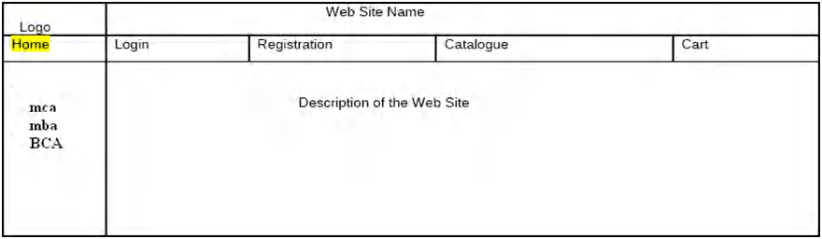

# LOGIN PAGE:

**(C) CATOLOGUE PAGE:**

The catalogue page should contain the details of all the books available in the web site in a table: The details should contain the following:

1. Snap shot of Cover Page.
2. Author Name.
3. Publisher.
4. Price.
5. Add to cart button.

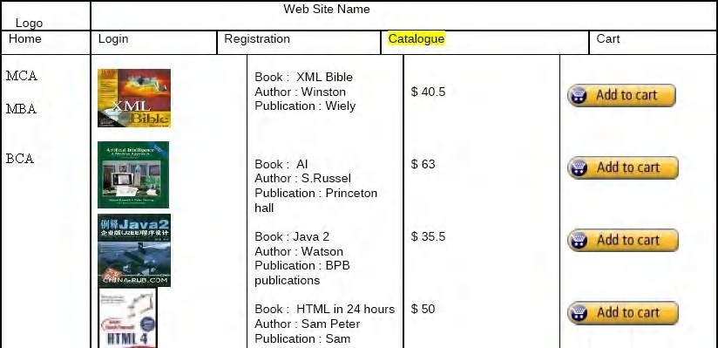

# (d). REGISTRATION PAGE:

1. Create a “*registration form* “with the following fields
   1. Name (Text field) 2) Password (password field)

3) E-mail id (text field) 4) Phone number (text field)

5) Sex (radio button) 6) Date of birth (3 select boxes) 7)Languages known (check boxes – English, Telugu, Hindi, Tamil) 8)Address (text area)

* 1. Design a web page using **CSS (C**ascading **S**tyle **S**heets**)** which includes the following: Use different font, styles: In the style definition you define how each selector should work (font, color etc.). Then, in the body of your pages, you refer to these selectors to activate the styles
  2. Design a dynamic web page with validation using JavaScript.
  3. Design a HTML having a text box and four buttons viz Factorial, Fibonacci, Prime, and Palindrome. When a button is pressed an appropriate javascript function should be called to display
     1. Factorial of that number
     2. Fibonacci series up to that number
     3. Prime numbers up to that number
     4. Is it palindrome or not
  4. Write JavaScript programs on Event Handling

1. Validation of registration form
2. Open a Window from the current window
3. Change color of background at each click of button or refresh ofa page
4. Display calendar for the month and year selected from combo box
5. On Mouse over event
   1. Write an XML file which will display the Book information which includes the following:

1) Title of the book 2) Author Name 3) ISBN number

4) Publisher name 5) Edition 6) Price

1. Write a Document Type Definition (DTD) to validate the above XML file.
2. Write a XML Schema Definition (XSD) to validate the above XML file.
   1. Create Web pages using AJAX.
   2. User Authentication:

Assume four users user1, user2, user3 and user4 having the passwords pwd1, pwd2, pwd3 and pwd4 respectively. Write a PHP for doing the following.

1. Create a Cookie and add these four user id’s and passwords to this Cookie.
2. Read the user id and passwords entered in the Login form (week1) and authenticate with the values (user id and passwords) available in the cookies.

If he is a valid user (i.e., user-name and password match) you should welcome him by name (user-name) else you should display “You are not an authenticated user ’’.Use init- parameters to do this..

* 1. Example PHP program for registering users of a website and login. 10)Install a database (Mysql or Oracle).

Create a table which should contain at least the following fields: name, password, email- id, phone number (these should hold the data from the registration form).

Write a PHP program to connect to that database and extract data from the tables and display them. Experiment with various SQL queries.

Insert the details of the users who register with the web site, whenever a new user clicks the submit button in the registration page (week2).

1. Write a PHP which does the following job: Insert the details of the 3 or 4 users who register with the web site (week9) by using registration form. Authenticate the user when he submits the login form using the user name and password from the database (similar to week8 instead of cookies).
2. Implement a Servlet program on request response processing.
3. Implement a Servlet program for Registration Page.
4. Connect to a database using JSP and practice SQL Queries (MySql or Oracle).

Experiment Mapping with Course Outcomes:

|  |  |  |  |
| --- | --- | --- | --- |
| Experiment name/number | Course Outcomes(CO’s) | Linkage with theory | Program Outcomes (PO’s) |
| 1 | CO 1. Ability to design and implement a basic web site | HTML | PO3,PO5,PO4 |
| 2,3,4 | CO 2. Implement different navigation strategies on web site. | DHTML,HTML | PO5,PO2 |
| *5* | CO 3. Effectively use client-side technologies (XHTML, CSS, forms and JavaScript) to implement static web sites. | HTML,CSS | PO5,PO2,PO3 |
| *6* | CO 4. Create an XML application. | XML | PO2,PO3,PO5 |
| 7-17,19,21,25 | CO 5. Use server-side technologies (PHP, RUBY and PERL) to implement dynamic web sites. | PHP,RUBY,PERL | PO2,PO5,PO9 |
| EX-18,20,22,23,24 | CO 6. Develop simple back-end database to support a web site. | MYSQL,PHP,PERL | PO3,PO5,PO9 |

**PROGRAM-1**

**AIM**

Left frame: At least four links for navigation, which will display the catalogue of respective links.  
Right frame: The pages to the links in the left frame must be loaded here. Initially this page contains  
description of the web site.

**2)login page**  
**3) CATOLOGUE PAGE:**  
The catalogue page should contain the details of all the books available in the web site in a table.  
The details should contain the following:  
1. Snap shot of Cover Page.  
2. Author Name.  
3. Publisher.  
4. Price.  
5. Add to cart button.

**Explanation:**

This program uses the following html tags to create static web pages**:**

**FRAMES**: HTML frames allow authors to present documents in multiple views.HTML frames are used to divide your browser window into multiple sections where each section can load a separate HTML document. A collection of frames in the browser window is known as a frameset. The window is divided into frames in a similar way the tables are organized: into rows and columns.

**IMAGE TAG**: Images are very important to beautify as well as to depict many complex concepts in simple way on your web page.we can insert any image in your web page by using **<img>** tag. The <img> tag is an empty tag, which means that it can contain only list of attributes and it has no closing tag.

**Anchor tag**: A webpage can contain various links that take you directly to other pages and even specific parts of a given page. These links are known as hyperlinks. A link is specified using HTML tag <a>. This tag is called **anchor tag.**

**Tabletag:** The HTML tables allow web authors to arrange data like text, images, links, other tables, etc. into rows and columns of cells. The HTML tables are created using the **<table>** tag in which the **<tr>** tag is used to create table rows and **<td>** tag is used to create data cells.

**Algorithm:**

**Step1:** Start

**Step2:** Create a HTML document.

**Step3:** Create frames Using <FRAMESET> tag divides the html page as preferred.

**Step4:** In top frame include the image of the college in the html document usingthe <img> tag and create links as home, login, register, catalogue and cart page.

**Step5:** In left frame create links as CSE, IT etc. and display the menu in the leftside of the window.

**Step6:** Make the respective forms to be displayed in the right side of web pagewhen the menu is clicked.

**Step7:** Stop.

**SourceCode:**

**1.HTML:**

<html>

<head>

<title>Collegeweb</title>

<frameset rows="20%,73%,7%">

<frame src="coll.html" frameborder=1>

<frameset cols="25%,75%">

<frame src="dept.html" frameborder=1>

<frame src="book.html" name="books" frameborder=1>

</frameset>

<frame src="info.html" frameborder=1>

</frameset>

</head>

</html>

**book.html:**

<html>

<body>

<h2 style="color:green"> You can see the corresponding books here </h2>

</body>

</html>

**COLL.HTML**

<html>

<body>

<h1 style="color:red" align="center"> WELCOME TO KKR&KSR INSTITUTE OF TECHNOLOGY AND SCIENCES </h1>

</body>

</html>

**DEPT.HTML:**

**<**html>

<head>

<style type="text/css">

a{font-size:35px;text-decoration="none"}

</style>

</head>

<body>

<h2> Departments</h2><br>

1.<a href="cse.html" target="books"> CSE </a><br>

2.<a href="ece.html" target="books"> ECE </a><br>

3.<a href="civil.html" target="books"> CIVIL </a>

</body>

</html>

**INFO.HTML:**

<html>

<body>

<center>

<pre>

By R.V.Kishore Kumar

Guntur

</pre>

</center>

</body>

</html>

**cse.html:**

<html>

<body>

<table border=0>

<tr>

<td><b>S.No. </b></td>

<td><b>Name Of The Subject</b></td>

<td><b>Image Of The Book </b></td>

<td><b> Author </b></td>

<td><b>Price</b></td>

</tr>

<tr>

<td> 1 </td>

<td> Embedded systems </td>

<td><img src="es.jpg" width="60" height="60"></td>

<td> Kenneth J.Ayala,Thomson </td>

<td> Rs.345</td>

</tr>

<tr>

<td> 2 </td>

<td> Web Technologies </td>

<td><img src="wt.jpg" width="60" height="60"></td>

<td> Chris Bates </td>

<td> Rs.600</td>

</tr>

<tr>

<td> 3 </td>

<td> Data WareHousing And Data Mining </td>

<td><img src="dmw.jpg" width="60" height="60"></td>

<td> Jiawei han&Micheline kamber Harcourt</td>

<td> Rs.450</td>

</tr>

<tr>

<td> 4 </td>

<td> Software project Management </td>

<td><img src="spm.jpg" width="60" height="60"></td>

<td> Walker Royce </td>

<td> Rs.400</td>

</tr>

<tr>

<td> 5 </td>

<td> Mobile Computing </td>

<td><img src="mc.jpg" width="60" height="60"></td>

<td> Jochen Schiller </td>

<td> Rs.399</td>

</tr>

<tr>

<td> 6 </td>

<td> Client Server Computing </td>

<td><img src="csc.jpg" width="60" height="60"></td>

<td> Robert Arfali and Dan Harkey</td>

<td> Rs.450</td>

</tr>

</table>

</body>

</html>

**ECE.HTML:**

<html>

<body>

<table border=0>

<tr>

<td><b>S.No. </b></td>

<td><b>Name Of The Subject</b></td>

<td><b>Image Of The Book </b></td>

<td><b> Author </b></td>

<td><b>Price</b></td>

</tr>

<tr>

<td> 1 </td>

<td> Computer Networks </td>

<td><img src="cn.jpg" width="60" height="60"></td>

<td> Andrew S Tenenbaum

<td> Rs.345

</tr>

<tr>

<td> 2 </td>

<td> Electronic measurements and instrumentation </td>

<td><img src="emi.jpg" width="60" height="60"></td>

<td> H.S.kalsi

<td> Rs.600

</tr>

<tr>

<td> 3 </td>

<td> Optical communication</td>

<td><img src="oc.jpg" width="60" height="60"></td>

<td> Gerd Keiser

<td> Rs.450

</tr>

<tr>

<td> 4 </td>

<td> Radar system </td>

<td><img src="rs.jpg" width="60" height="60"></td>

<td> Merrill l. Skolnik

<td> Rs.400

</tr>

<tr>

<td> 5 </td>

<td> Operating system </td>

<td><img src="os.jpg" width="60" height="60"></td>

<td> Abraham silberchatz

<td> Rs.399

</tr>

<tr>

<td> 6 </td>

<td> Digital image processing </td>

<td><img src="dip.jpg" width="60" height="60"></td>

<td> R.c gonzalez & R.E woods

<td> Rs.450

</tr>

</table>

</body>

</html>

**CIVIL.HTML:**

<html>

<body>

<table border=0>

<tr>

<td><b>S.No. </b></td>

<td><b>Name Of The Subject</b></td>

<td><b>Image Of The Book </b></td>

<td><b> Author </b></td>

<td><b>Price</b></td>

</tr>

<tr>

<td> 1 </td>

<td>Geotechnical engineering2 </td>

<td><img src="geo.jpg" width="60" height="60"></td>

<td> Gopal Ranjan </td>

<td> Rs.345</td>

</tr>

<tr>

<td> 2 </td>

<td> Air polution and control </td>

<td><img src="apc.jpg" width="60" height="60"></td>

<td> MN Rao </td>

<td> Rs.600</td>

</tr>

<tr>

<td> 3 </td>

<td> Finite element method in engg </td>

<td><img src="fem.jpg" width="60" height="60"></td>

<td> Tirupath r chandrapath </td>

<td> Rs.450</td>

</tr>

<tr>

<td> 4 </td>

<td> Remote sensing and GSI Application </td>

<td><img src="rsg.jpg" width="60" height="60"></td>

<td> LRA Narayana </td>

<td> Rs.400</td>

</tr>

<tr>

<td> 5 </td>

<td> Environment engineering2 </td>

<td><img src="env.jpg" width="60" height="60"></td>

<td> JG Henry</td>

<td> Rs.399</td>

</tr>

<tr>

<td> 6 </td>

<td> Earthquake resistant design </td>

<td><img src="eaq.gif" width="60" height="60"></td>

<td> Clough</td>

<td> Rs.450</td>

</tr>

</table>

</body>

</html>

**Sample OutPut:**

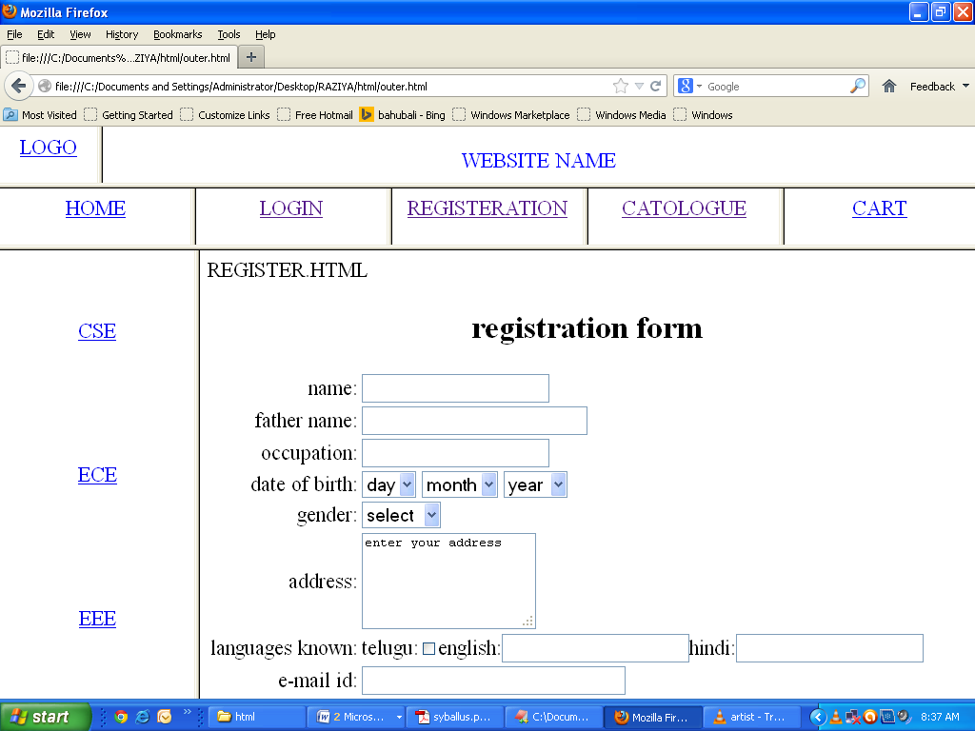





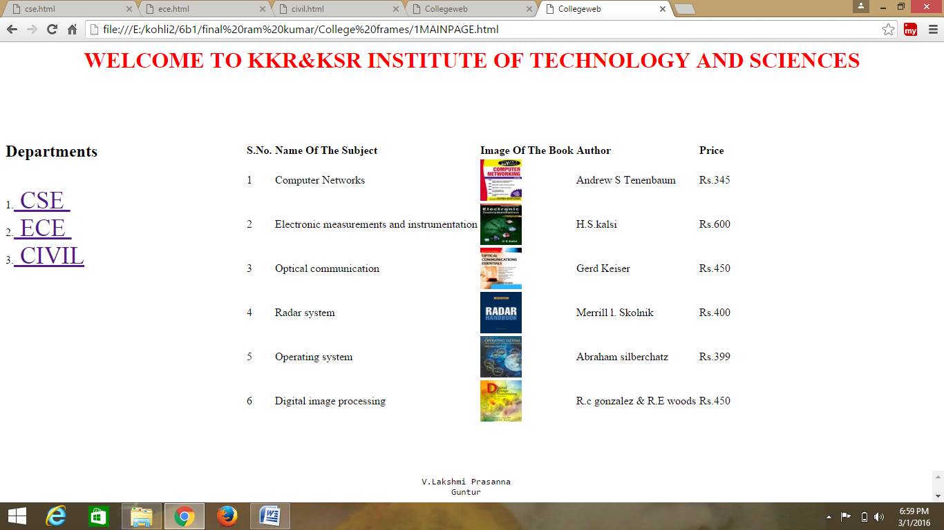

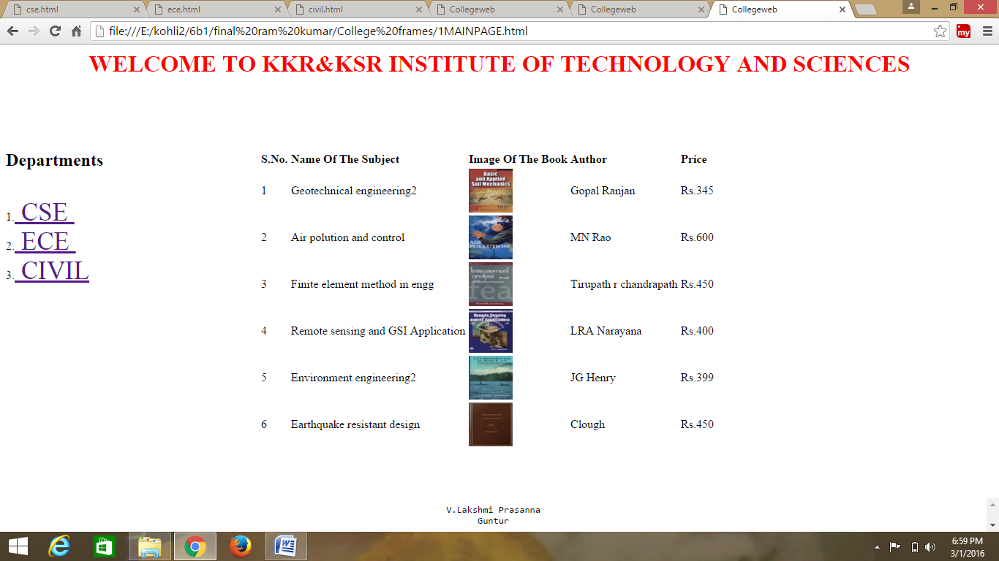

**VIVA QUESTIONS:**

1. What are the basic tags used to develop a webpage?
2. What are the attributes of frameset tag?
3. What is the use of anchor tag?
4. What are the properties of table tag?
5. What are the difference between cell padding and cell spacing?

**PROGRAM-2**

**Aim:**A html code to prepare CSS

**Decription:**To prepare a web page using css which includes all the css properties.

**Algorithm:**

Step 1:Create a web page and save it with .html extension.

Step 2:Use <style> tag in <head> tag and include the css properties in that <style> tag.

Step 3:The css attributes include font-size,font-family,background-color etc.,

Step 4:Use z-index attribute to define the order of stack of elements and also use <div> tag to hold the other tags.

Step 5:Close the tags properly and display it on the web page.

Step 6:Stop

**Source Code:**

**css.html:**

<html>

<head>

<h1 align=center> Web Page using CSS </h1>

<style type="text/css">

body{background-image:url(img2.jpg); background-repeat:repeat-y;}

p{color:yellow ;font-size:20pt;font-family:chiller;background-image:url(img1.jpg);}

a:hover{font-size:20pt;background-color:yellow;cursor:crosshair;}

a:link{font-size:20pt;background-color:white;}

a:active{font-size:20pt;background-color:cyan;cursor:help;}

a:visited{font-size:20pt;background-color:tan;}

</style>

</head>

<title> CSS Webpage!!! </title>

<body>

<br>

<p> Weclome to Web page using CSS where CSS means Cascading Style Sheets! using CSS we can apply the common styles to different tags and also different styles to same tag i.e. repeated more than once in the html file </p>

<a href="sample1.html"><center> Register </center.</a>

<br><br><br><br><br><br><br><br><br>

<center>

<div style="position:relative;font-size:50px;z-index:2;">LAYER 1</div>

<div style="position:relative;top:50;left:5;color:red;font-size:80px;z-index:1;">LAYER 2</div>

<div style="position:relative;font-size:50px;z-index:3;">LAYER 1</div>

<div style="position:relative;top:50;left:5;color:red;font-size:80px;z-index:4;">LAYER 2</div>

</center>

</body>

</html>

**Sample Output**: after execution css.html this is output

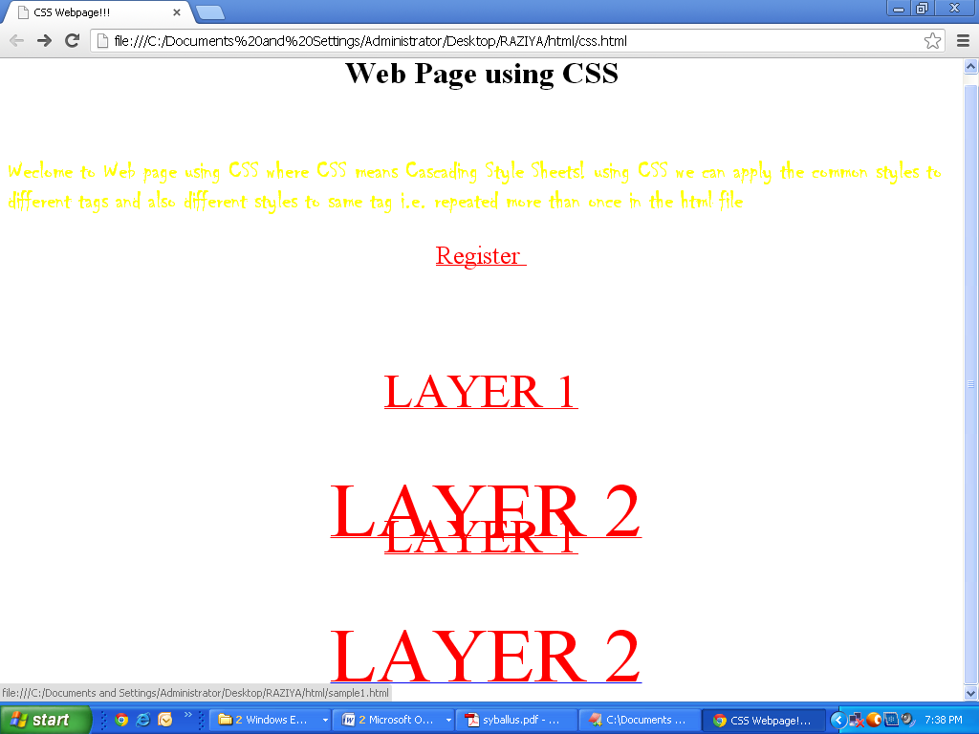

**VIVA QUESTIONS:**

1. What is internal, external inline css?
2. What are the differnent border properties?
3. What is z-index?
4. What are the psedo element and pseuo block?
5. What are postion:absulote and relative.

**PROGRAM-3**

**Aim**: Design a dynamic web page with validation using JavaScript.

**Decription:**To prepare a web page with validation using JavaScript.

**Source Code:**

<!DOCTYPE html>

<html lang="en">

<head>

<meta charset="UTF-8">

<title>JavaScript Form validation</title>

<link rel="stylesheet" href="/examples/css/form-style.css">

<script>

// Defining a function to display error message

function printError(elemId, hintMsg) {

document.getElementById(elemId).innerHTML = hintMsg;

}

// Defining a function to validate form

function validateForm() {

// Retrieving the values of form elements

var name = document.contactForm.name.value;

var email = document.contactForm.email.value;

var mobile = document.contactForm.mobile.value;

var country = document.contactForm.country.value;

var gender = document.contactForm.gender.value;

var hobbies = [];

var checkboxes = document.getElementsByName("hobbies[]");

for(var i=0; i < checkboxes.length; i++) {

if(checkboxes[i].checked) {

// Populate hobbies array with selected values

hobbies.push(checkboxes[i].value);

}

}

// Defining error variables with a default value

var nameErr = emailErr = mobileErr = countryErr = genderErr = true;

// Validate name

if(name == "") {

printError("nameErr", "Please enter your name");

} else {

var regex = /^[a-zA-Z\s]+$/;

if(regex.test(name) === false) {

printError("nameErr", "Please enter a valid name");

} else {

printError("nameErr", "");

nameErr = false;

}

}

// Validate email address

if(email == "") {

printError("emailErr", "Please enter your email address");

} else {

// Regular expression for basic email validation

var regex = /^\S+@\S+\.\S+$/;

if(regex.test(email) === false) {

printError("emailErr", "Please enter a valid email address");

} else{

printError("emailErr", "");

emailErr = false;

}

}

// Validate mobile number

if(mobile == "") {

printError("mobileErr", "Please enter your mobile number");

} else {

var regex = /^[1-9]\d{9}$/;

if(regex.test(mobile) === false) {

printError("mobileErr", "Please enter a valid 10 digit mobile number");

} else{

printError("mobileErr", "");

mobileErr = false;

}

}

// Validate country

if(country == "Select") {

printError("countryErr", "Please select your country");

} else {

printError("countryErr", "");

countryErr = false;

}

// Validate gender

if(gender == "") {

printError("genderErr", "Please select your gender");

} else {

printError("genderErr", "");

genderErr = false;

}

// Prevent the form from being submitted if there are any errors

if((nameErr || emailErr || mobileErr || countryErr || genderErr) == true) {

return false;

} else {

// Creating a string from input data for preview

var dataPreview = "You've entered the following details: \n" +

"Full Name: " + name + "\n" +

"Email Address: " + email + "\n" +

"Mobile Number: " + mobile + "\n" +

"Country: " + country + "\n" +

"Gender: " + gender + "\n";

if(hobbies.length) {

dataPreview += "Hobbies: " + hobbies.join(", ");

}

// Display input data in a dialog box before submitting the form

alert(dataPreview);

}

};

</script>

</head>

<body>

<form name="contactForm" onsubmit="return validateForm()" action="/examples/actions/confirmation.php" method="post">

<h2>Application Form</h2>

<div class="row">

<label>Full Name</label>

<input type="text" name="name">

<div class="error" id="nameErr"></div>

</div>

<div class="row">

<label>Email Address</label>

<input type="text" name="email">

<div class="error" id="emailErr"></div>

</div>

<div class="row">

<label>Mobile Number</label>

<input type="text" name="mobile" maxlength="10">

<div class="error" id="mobileErr"></div>

</div>

<div class="row">

<label>Country</label>

<select name="country">

<option>Select</option>

<option>Australia</option>

<option>India</option>

<option>United States</option>

<option>United Kingdom</option>

</select>

<div class="error" id="countryErr"></div>

</div>

<div class="row">

<label>Gender</label>

<div class="form-inline">

<label><input type="radio" name="gender" value="male"> Male</label>

<label><input type="radio" name="gender" value="female"> Female</label>

</div>

<div class="error" id="genderErr"></div>

</div>

<div class="row">

<label>Hobbies <i>(Optional)</i></label>

<div class="form-inline">

<label><input type="checkbox" name="hobbies[]" value="sports"> Sports</label>

<label><input type="checkbox" name="hobbies[]" value="movies"> Movies</label>

<label><input type="checkbox" name="hobbies[]" value="music"> Music</label>

</div>

</div>

<div class="row">

<input type="submit" value="Submit">

</div>

</form>

</body>

</html>

**Sample Output**: after execution css.html this is output

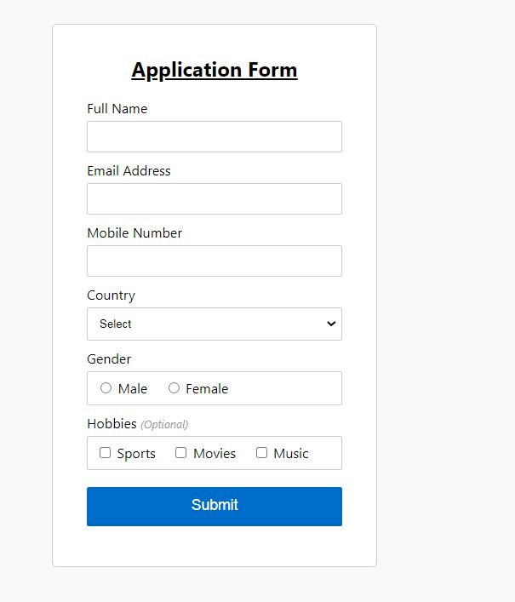

**PROGRAM-4**

**Aim**: Design a HTML having a text box and four buttons viz Factorial, Fibonacci, Prime, and

Palindrome. When a button is pressed an appropriate javascript function should be called

to display

a. Factorial of that number

b. Fibonacci series up to that number

c. Prime numbers up to that number

d. Is it palindrome or not

**A.** Factorial of that number

<!DOCTYPE html**>**

**<html>**

**<head>**

**</head>**

**<body** style = "text-align: center; font-size: 20px;"**>**

**<h1>** Welcome to the javaTpoint.com **</h1>**

Enter a number: **<input** id = "num"**>**

**<br><br>**

**<button** onclick = "fact()"**>** Factorial **</button>**

**<p** id = "res"**></p>**

**<script>**

function fact(){

var i, num, f;

f = 1;

num = document.getElementById("num").value;

for(i = 1; i **<**= num; i++)

{

ff = f * i;

}

ii = i - 1;

document.getElementById("res").innerHTML = "The factorial of the number " + i + " is: " + f ;

}

**</script>**

**</body>**

**</html>**

[**Test it Now**](https://www.javatpoint.com/oprweb/test.jsp?filename=how-to-find-factorial-of-a-number-in-javascript1)

**Output**

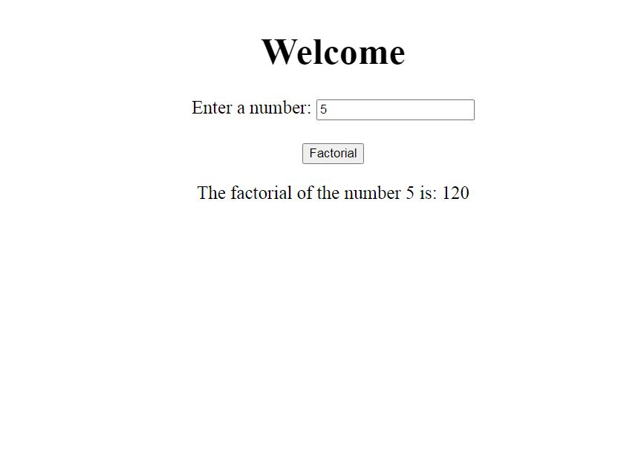

**B. Fibonacci series up to that number**

**<html>**

**<head>**

**<title>** Fibonacci Series in JavaScript **</title>**

**</head>**

**<body>**

**<script>**

// declaration of the variables

var n1 = 0,  n2 = 1, next_num, i;

var num = parseInt (prompt (" Enter the limit for Fibonacci Series "));

document.write( "Fibonacci Series: ");

for ( i = 1; i **<**= num; i++)

{  document.write (" **<br>** " +  n1); // print the n1

    next_num = n1 + n2; // sum of n1 and n2 into the next_num

    n1 = n2; // assign the n2 value into n2

    n2 = next_num; // assign the next_num into n2

}

**</script>**

**</body>**

**</html>**

**Output:**

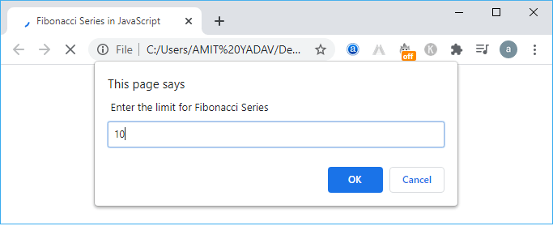

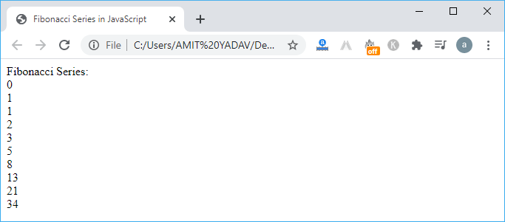

**C.** Prime numbers up to that number

**html code**

<head>

<meta charset="utf-8">

<title>JavaScript function to get all prime numbers from 0 to num</title>

</head>

<body>

</body>

**Java Script**

function primeFactorsTo(max)

{

var store = [], i, j, primes = [];

for (i = 2; i <= max; ++i)

{

if (!store [i])

{

primes.push(i);

for (j = i << 1; j <= max; j += i)

{

store[j] = true;

}

}

}

return primes;

}

console.log(primeFactorsTo(5));

console.log(primeFactorsTo(15));

**Output**

[2,3,5]

[2,3,5,7,11,13]

**PROGRAM-5**

**Aim**: Write JavaScript programs on Event Handling

a. Validation of registration form

b. Open a Window from the current window

c. Change color of background at each click of button or refresh of a

page

d. Display calendar for the month and year selected from combo box

e. On Mouse over event

1. **Validation of registration form**

**HTML Code of the Sample Registration Form**

<!DOCTYPE html>

<html lang="en"><head>

<meta charset="utf-8">

<title>JavaScript Form Validation using a sample registration form</title>

<meta name="keywords" content="example, JavaScript Form Validation, Sample registration form" />

<meta name="description" content="This document is an example of JavaScript Form Validation using a sample registration form. " />

<link rel='stylesheet' href='js-form-validation.css' type='text/css' />

<script src="sample-registration-form-validation.js"></script>

</head>

<body onload="document.registration.userid.focus();">

<h1>Registration Form</h1>

Use tab keys to move from one input field to the next.

<form name='registration' onSubmit="return formValidation();">

<ul>

<li><label for="userid">User id:</label></li>

<li><input type="text" name="userid" size="12" /></li>

<li><label for="passid">Password:</label></li>

<li><input type="password" name="passid" size="12" /></li>

<li><label for="username">Name:</label></li>

<li><input type="text" name="username" size="50" /></li>

<li><label for="address">Address:</label></li>

<li><input type="text" name="address" size="50" /></li>

<li><label for="country">Country:</label></li>

<li><select name="country">

<option selected="" value="Default">(Please select a country)</option>

<option value="AF">Australia</option>

<option value="AL">Canada</option>

<option value="DZ">India</option>

<option value="AS">Russia</option>

<option value="AD">USA</option>

</select></li>

<li><label for="zip">ZIP Code:</label></li>

<li><input type="text" name="zip" /></li>

<li><label for="email">Email:</label></li>

<li><input type="text" name="email" size="50" /></li>

<li><label id="gender">Sex:</label></li>

<li><input type="radio" name="msex" value="Male" /><span>Male</span></li>

<li><input type="radio" name="fsex" value="Female" /><span>Female</span></li>

<li><label>Language:</label></li>

<li><input type="checkbox" name="en" value="en" checked /><span>English</span></li>

<li><input type="checkbox" name="nonen" value="noen" /><span>Non English</span></li>

<li><label for="desc">About:</label></li>

<li><textarea name="desc" id="desc"></textarea></li>

<li><input type="submit" name="submit" value="Submit" /></li>

</ul>

</form>

</body>

</html>

**CSS Code of the Sample Registration Form**

h1 {

margin-left: 70px;

}

form li {

list-style: none;

margin-bottom: 5px;

}

form ul li label{

float: left;

clear: left;

width: 100px;

text-align: right;

margin-right: 10px;

font-family:Verdana, Arial, Helvetica, sans-serif;

font-size:14px;

}

form ul li input, select, span {

float: left;

margin-bottom: 10px;

}

form textarea {

float: left;

width: 350px;

height: 150px;

}

[type="submit"] {

clear: left;

margin: 20px 0 0 230px;

font-size:18px

}

p {

margin-left: 70px;

font-weight: bold;

}

**JavaScript code for validation**

function formValidation()

{

var uid = document.registration.userid;

var passid = document.registration.passid;

var uname = document.registration.username;

var uadd = document.registration.address;

var ucountry = document.registration.country;

var uzip = document.registration.zip;

var uemail = document.registration.email;

var umsex = document.registration.msex;

var ufsex = document.registration.fsex; if(userid_validation(uid,5,12))

{

if(passid_validation(passid,7,12))

{

if(allLetter(uname))

{

if(alphanumeric(uadd))

{

if(countryselect(ucountry))

{

if(allnumeric(uzip))

{

if(ValidateEmail(uemail))

{

if(validsex(umsex,ufsex))

{

}

}

}

}

}

}

}

}

return false;

}

**JavaScript function for validating userid**

function userid_validation(uid,mx,my)

{

var uid_len = uid.value.length;

if (uid_len == 0 || uid_len >= my || uid_len < mx)

{

alert("User Id should not be empty / length be between "+mx+" to "+my);

uid.focus();

return false;

}

return true;

}

**JavaScript function for validating password**

function passid_validation(passid,mx,my)

{

var passid_len = passid.value.length;

if (passid_len == 0 ||passid_len >= my || passid_len < mx)

{

alert("Password should not be empty / length be between "+mx+" to "+my);

passid.focus();

return false;

}

return true;

}

**JavaScript code for validating user name**

function allLetter(uname)

{

var letters = /^[A-Za-z]+$/;

if(uname.value.match(letters))

{

return true;

}

else

{

alert('Username must have alphabet characters only');

uname.focus();

return false;

}

}

**JavaScript code for validating user address**

function alphanumeric(uadd)

{

var letters = /^[0-9a-zA-Z]+$/;

if(uadd.value.match(letters))

{

return true;

}

else

{

alert('User address must have alphanumeric characters only');

uadd.focus();

return false;

}

}

**JavaScript code for validating country**

function countryselect(ucountry)

{

if(ucountry.value == "Default")

{

alert('Select your country from the list');

ucountry.focus();

return false;

}

else

{

return true;

}

}

**JavaScript code for validating ZIP code**

function allnumeric(uzip)

{

var numbers = /^[0-9]+$/;

if(uzip.value.match(numbers))

{

return true;

}

else

{

alert('ZIP code must have numeric characters only');

uzip.focus();

return false;

}

}

**JavaScript code for validating email format**

function ValidateEmail(uemail)

{

var mailformat = /^\w+([\.-]?\w+)*@\w+([\.-]?\w+)*(\.\w{2,3})+$/;

if(uemail.value.match(mailformat))

{

return true;

}

else

{

alert("You have entered an invalid email address!");

uemail.focus();

return false;

}

}

**JavaScript code for validating gender**

function validsex(umsex,ufsex)

{

x=0;

if(umsex.checked)

{

x++;

} if(ufsex.checked)

{

x++;

}

if(x==0)

{

alert('Select Male/Female');

umsex.focus();

return false;

}

else

{

alert('Form Successfully Submitted');

window.location.reload()

return true;}

}

**Here is the entire JavaScript used for validation of the form**

function formValidation()

{

var uid = document.registration.userid;

var passid = document.registration.passid;

var uname = document.registration.username;

var uadd = document.registration.address;

var ucountry = document.registration.country;

var uzip = document.registration.zip;

var uemail = document.registration.email;

var umsex = document.registration.msex;

var ufsex = document.registration.fsex; if(userid_validation(uid,5,12))

{

if(passid_validation(passid,7,12))

{

if(allLetter(uname))

{

if(alphanumeric(uadd))

{

if(countryselect(ucountry))

{

if(allnumeric(uzip))

{

if(ValidateEmail(uemail))

{

if(validsex(umsex,ufsex))

{

}

}

}

}

}

}

}

}

return false;

} function userid_validation(uid,mx,my)

{

var uid_len = uid.value.length;

if (uid_len == 0 || uid_len >= my || uid_len < mx)

{

alert("User Id should not be empty / length be between "+mx+" to "+my);

uid.focus();

return false;

}

return true;

}

function passid_validation(passid,mx,my)

{

var passid_len = passid.value.length;

if (passid_len == 0 ||passid_len >= my || passid_len < mx)

{

alert("Password should not be empty / length be between "+mx+" to "+my);

passid.focus();

return false;

}

return true;

}

function allLetter(uname)

{

var letters = /^[A-Za-z]+$/;

if(uname.value.match(letters))

{

return true;

}

else

{

alert('Username must have alphabet characters only');

uname.focus();

return false;

}

}

function alphanumeric(uadd)

{

var letters = /^[0-9a-zA-Z]+$/;

if(uadd.value.match(letters))

{

return true;

}

else

{

alert('User address must have alphanumeric characters only');

uadd.focus();

return false;

}

}

function countryselect(ucountry)

{

if(ucountry.value == "Default")

{

alert('Select your country from the list');

ucountry.focus();

return false;

}

else

{

return true;

}

}

function allnumeric(uzip)

{

var numbers = /^[0-9]+$/;

if(uzip.value.match(numbers))

{

return true;

}

else

{

alert('ZIP code must have numeric characters only');

uzip.focus();

return false;

}

}

function ValidateEmail(uemail)

{

var mailformat = /^\w+([\.-]?\w+)*@\w+([\.-]?\w+)*(\.\w{2,3})+$/;

if(uemail.value.match(mailformat))

{

return true;

}

else

{

alert("You have entered an invalid email address!");

uemail.focus();

return false;

}

} function validsex(umsex,ufsex)

{

x=0;

if(umsex.checked)

{

x++;

} if(ufsex.checked)

{

x++;

}

if(x==0)

{

alert('Select Male/Female');

umsex.focus();

return false;

}

else

{

alert('Form Succesfully Submitted');

window.location.reload()

return true;

}

}

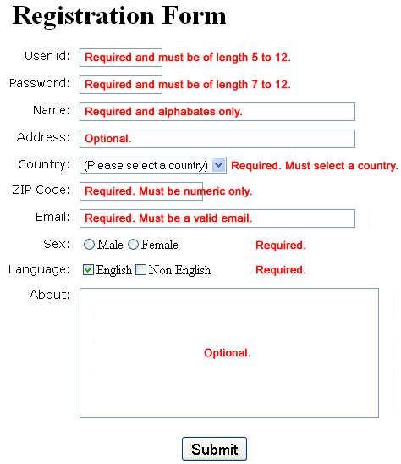

1. **Open a Window from the current window**

<!DOCTYPE html>

<html>

<body>

<h1>The Window Object</h1>

<h2>The open() Method</h2>

<p>Click the button to open a new browser window.</p>

<button onclick="myFunction()">Try it</button>

<script>

function myFunction() {

window.open("https://www.simplesite.com/app/v5/#/pages/437140560?editmode=true#anchor437140560");

}

</script>

</body>

</html>

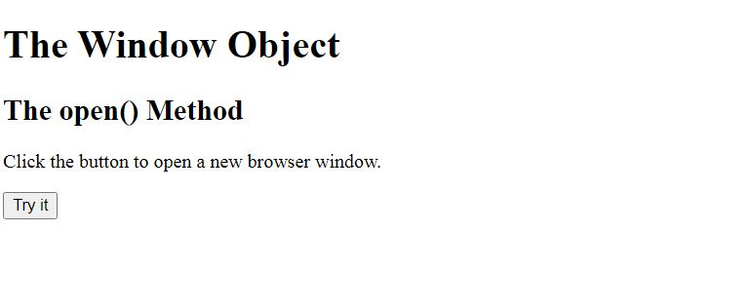

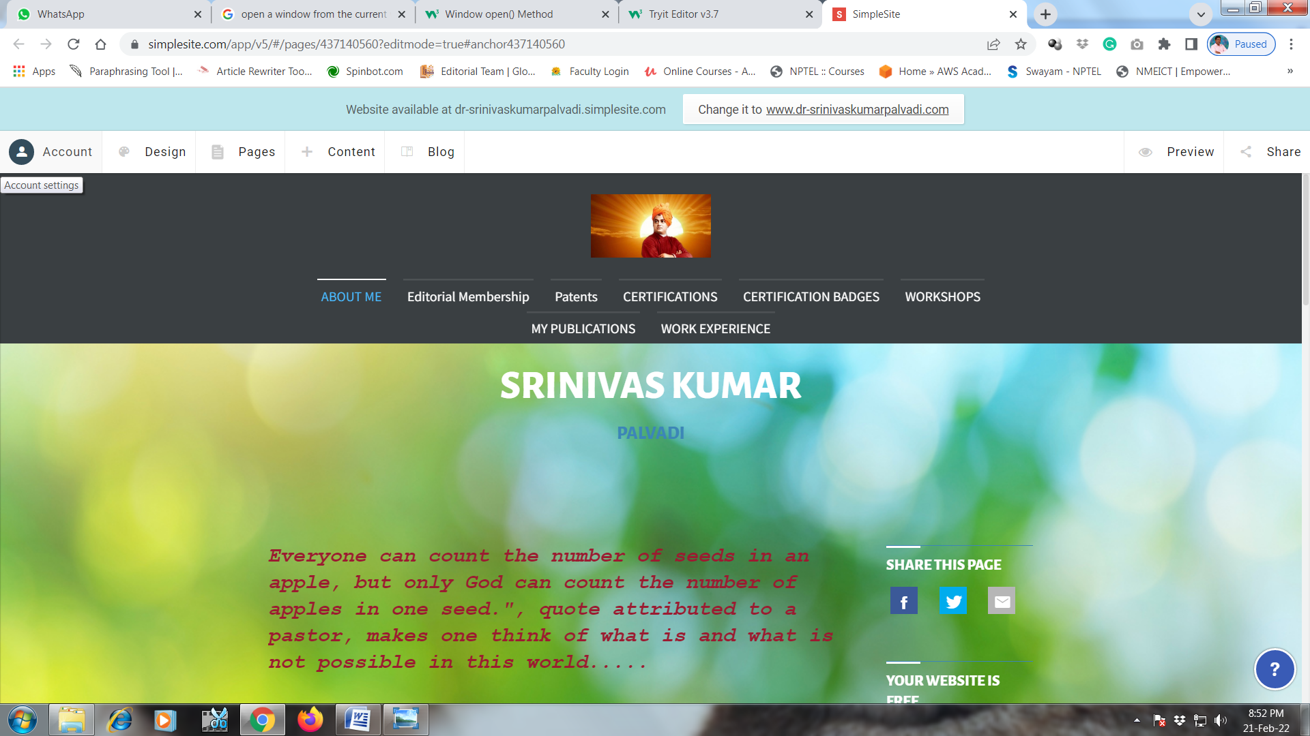

1. **Change color of background at each click of button or refresh of a page**

<!DOCTYPE HTML>

<html>

<head>

<title>

How to change the background color

after clicking the button ?

</title>

</head>

<body style = "text-align:center;">

<h1 style = "color:green;" >

Srinivas

</h1>

<p id = "GFG_UP" style =

"font-size: 16px; font-weight: bold;">

</p>

<button onclick = "gfg_Run()">

Click here

</button>

<p id = "GFG_DOWN" style =

"color:green; font-size: 20px; font-weight: bold;">

</p>

<script>

var el_up = document.getElementById("GFG_UP");

var el_down = document.getElementById("GFG_DOWN");

var str = "Click on button to change the background color";

el_up.innerHTML = str;

function changeColor(color) {

document.body.style.background = color;

}

function gfg_Run() {

changeColor('yellow');

el_down.innerHTML = "Background Color changed";

}

</script>

</body>

</html>

**Output**

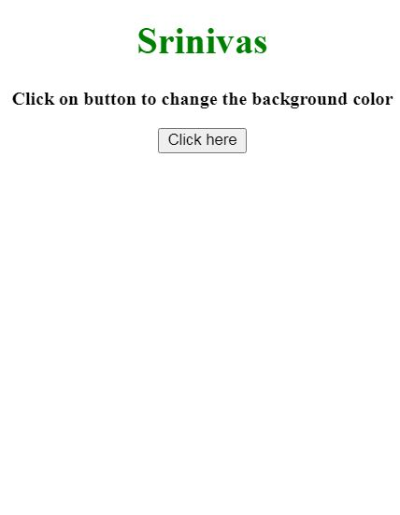

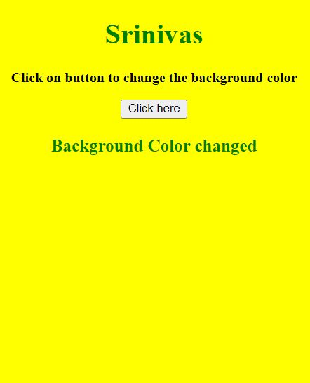

1. **Display calendar for the month and year selected from combo box**

<meta http-equiv="Content-Type" content="text/html; charset=windows-1252">

<html>

<head>

<title>Demo </title>

<META NAME="DESCRIPTION" CONTENT=" ">

<META NAME="KEYWORDS" CONTENT="">

<script type="text/javascript">

var dt_obj= new Date();

function addOption(selectbox,text,value )

{

var optn = document.createElement("OPTION");

optn.text = text;

optn.value = value;

selectbox.options.add(optn);

}

///////////// date //////////////////

var today_date= dt_obj.getDate();

function addOption_list1(){

for (var i=1; i < 32;++i){

addOption(document.drop_list.dt_list, i, i);

if(i== today_date){document.drop_list.dt_list.options[i].selected=true;}

}

addOption_list2();

}

//////////////End of Date //////////

///////////// Month //////////////////

var current_month=dt_obj.getMonth() +1;

function addOption_list2(){

var month = new Array("January","February","March","April","May","June","July","August","September","October","November","December");

for (var i=0; i < month.length;++i){

addOption(document.drop_list.Month_list, month[i], month[i]);

if(i== current_month){document.drop_list.Month_list.options[i].selected=true;}

}

addOption_list3();

}

//////////////End of Month //////////

///////////// Year //////////////////

var current_year=dt_obj.getFullYear();

function addOption_list3(){

for (var i=0; i < 7;++i){

var j=current_year+i-2;

match_year=current_year+i;

addOption(document.drop_list.year_list, j, j);

if((j-1)== current_year ){document.drop_list.year_list.options[i].selected=true;}

}

}

//////////////End of Year //////////

</script>

</head>

<body onload=addOption_list1();>

<FORM name="drop_list" action="date-projects2ck.php" method="POST" >

<SELECT NAME="dt_list">

<Option value="" >Date</option>

</SELECT>

<SELECT NAME="Month_list">

<Option value="" >Month</option>

</SELECT>

<SELECT NAME="year_list">

<Option value="" >Year</option>

</SELECT>

<input type=submit value=submit>

</form>

</body>

</html>

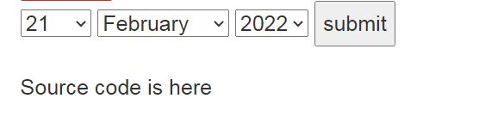

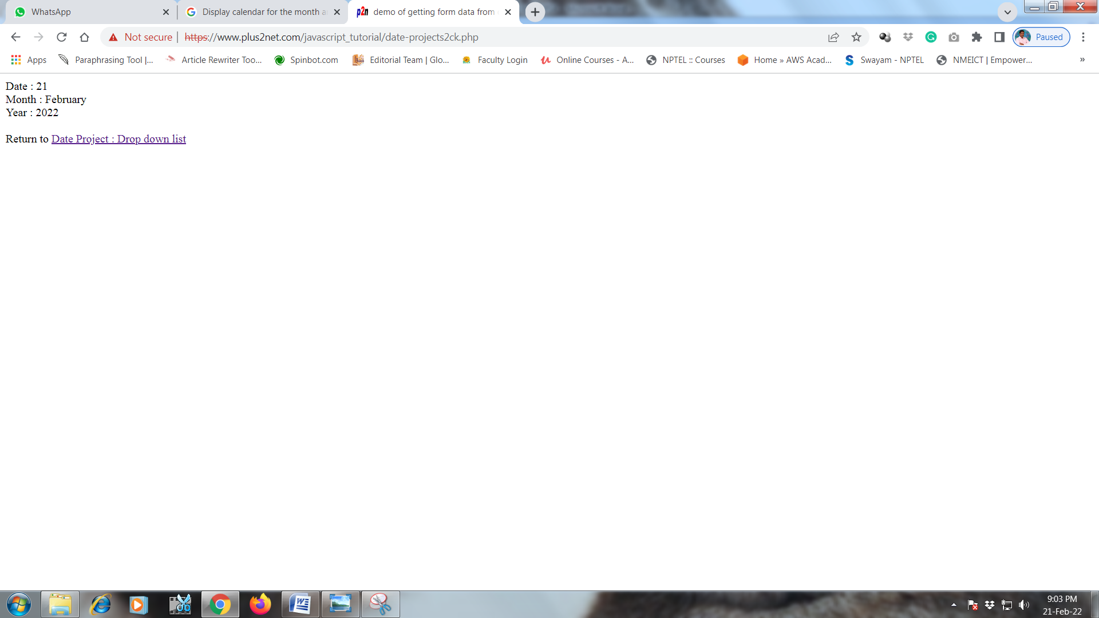

1. **On Mouse over event**

<!DOCTYPE html>

<html>

<body>

<img onmouseover="bigImg(this)" onmouseout="normalImg(this)" border="0" src="smiley.gif" alt="Smiley" width="32" height="32">

<p>The function bigImg() is triggered when the user moves the mouse pointer over the image.</p>

<p>The function normalImg() is triggered when the mouse pointer is moved out of the image.</p>

<script>

function bigImg(x) {

x.style.height = "64px";

x.style.width = "64px";

}

function normalImg(x) {

x.style.height = "32px";

x.style.width = "32px";

}

</script>

</body>

</html>

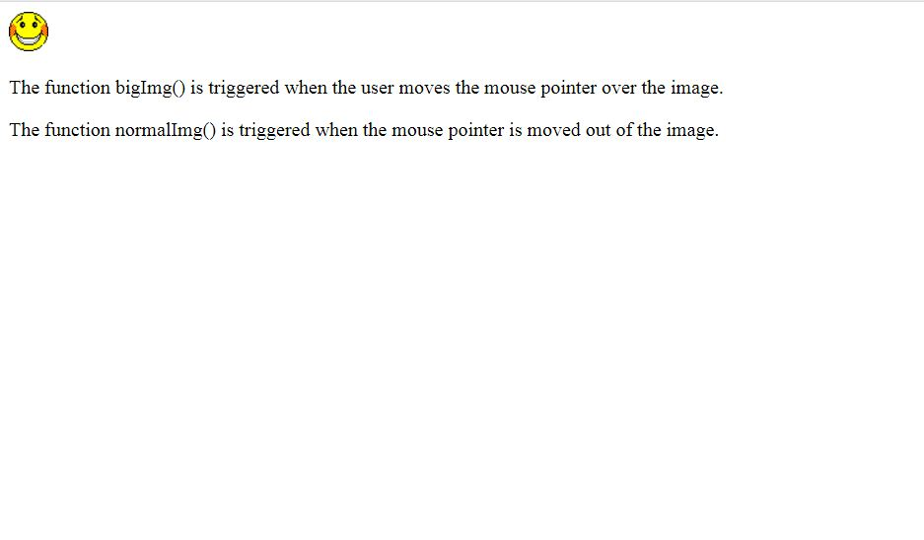

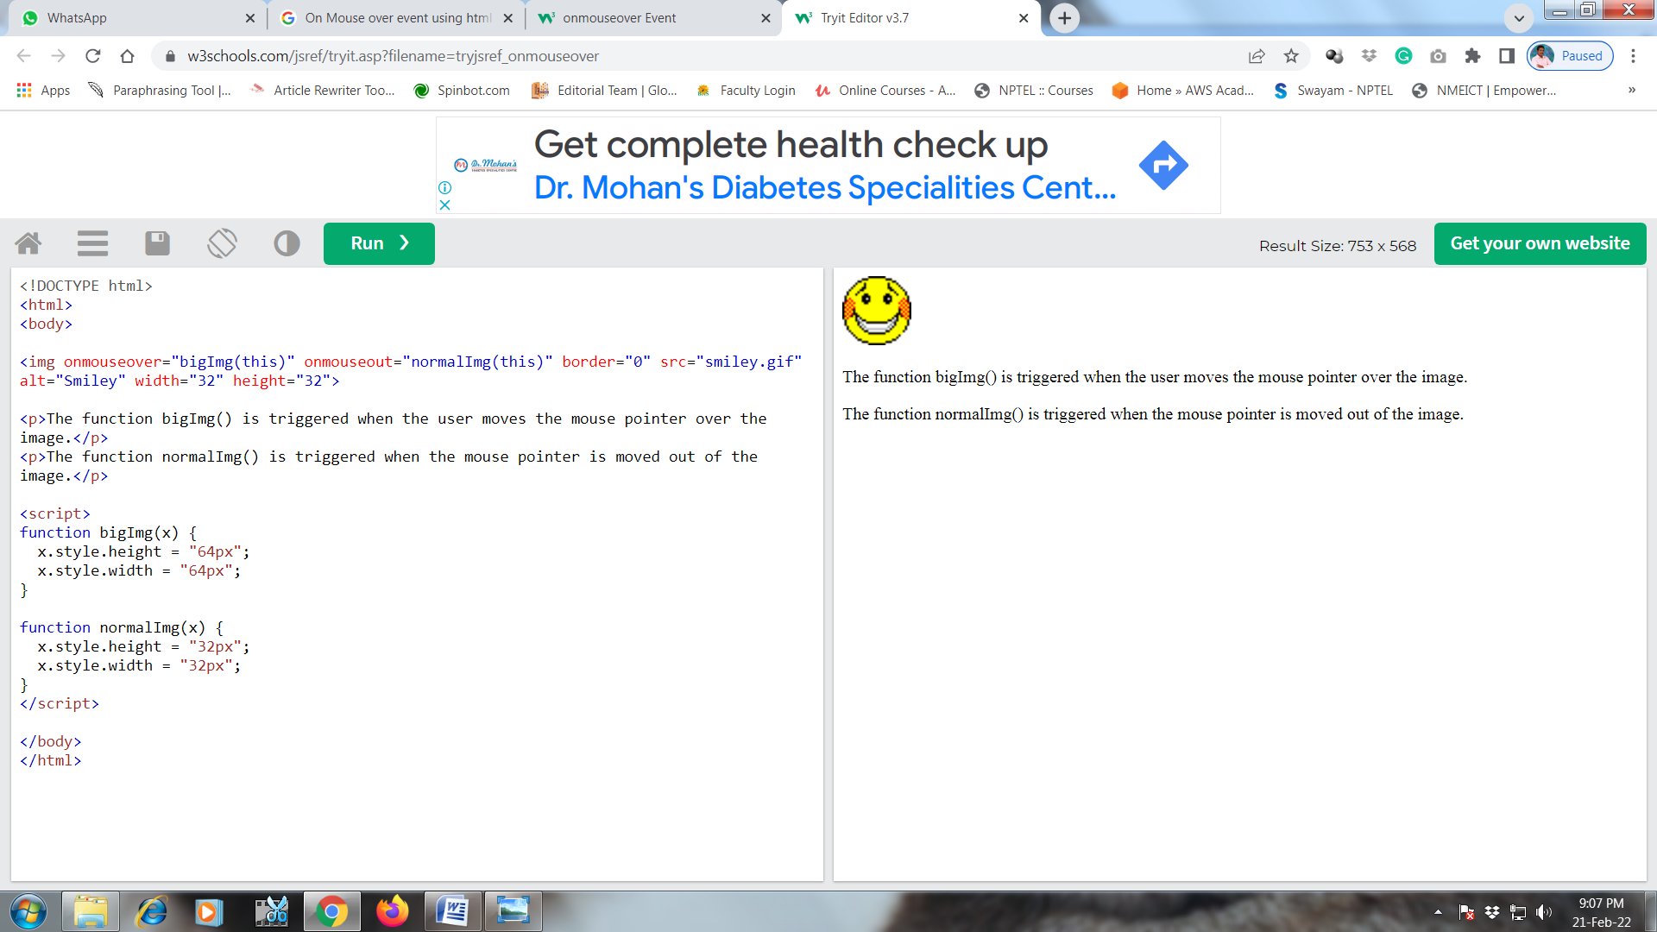

**PROGRAM-6**

**Aim:** To create an xml file which displays the book details.

**Description:** To create an xml file which displays the book details that includes the following:

1)Title of the book

2)Author Name

3)Edition

4)Price

Write a DTD to validate the above xml and display the details in a table.

**Algorithm:**

**Step**1:First create a DTD file as book.dtd using the elements,attribute syntax <!ELEMENT bookstore (book+)>,<!ELEMENT book (title,author,price)>

.**Step2**:Next create an xml file as book.xml.using predefined tags like <title> ADVANCED JAVA </title>

**Step3**:use xsl:for-each statement to display the data of book.xsl.

**Step4**:<td><xsl:value-of select="title"/></td> using statement get the value of xml document

**Step5**:Run the open xsl file in browser to get desired output.

**Step 6** stop

**Source Code:**

**CART.XML**

<?xml version="1.0"?>

<bookstore>

<book>

<title> ADVANCED JAVA </title>

<author> HERBERT SCHILDT </author>

<price> 500 </price>

</book>

<book>

<title> WEB TECHNOLOGIES </title>

<author> BLACK BOOK </author>

<price> 550 </price>

</book>

<book>

<title> OPERATING SYSTEMS </title>

<author> GALVIN </author>

<price> 400 </price>

</book>

<book>

<title> COMPILER DESIGN </title>

<author> JEFFREY D.ULLMAN </author>

<price> 350 </price>

</book>

</bookstore>

**Sample output screens**

**Output:**

after execution cart.xml this is output

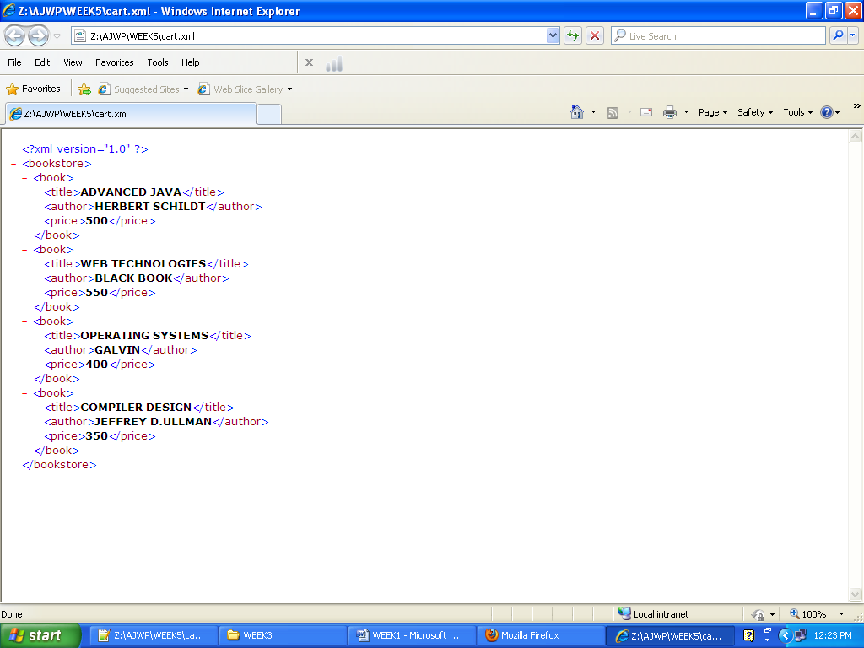

**CART.XML**

<?xml version="1.0"?>

<!DOCTYPE bookstore SYSTEM "book.dtd">

<bookstore>

<book>

<title> ADVANCED JAVA </title>

<author> HERBERT SCHILDT </author>

<price> 500 </price>

</book>

<book>

<title> WEB TECHNOLOGIES </title>

<author> BLACK BOOK </author>

<price> 550 </price>

</book>

<book>

<title> OPERATING SYSTEMS </title>

<author> GALVIN </author>

<price> 400 </price>

</book>

<book>

<title> COMPILER DESIGN </title>

<author> JEFFREY D.ULLMAN </author>

<price> 350 </price>

</book>

</bookstore>

**BOOK.DTD**

<!ELEMENT bookstore (book+)>

<!ELEMENT book (title,author,price)>

<!ELEMENT title (#PCDATA)>

<!ELEMENT author (#PCDATA)>

<!ELEMENT price (#PCDATA)>

**Output:**

after execution cart.xml this is output

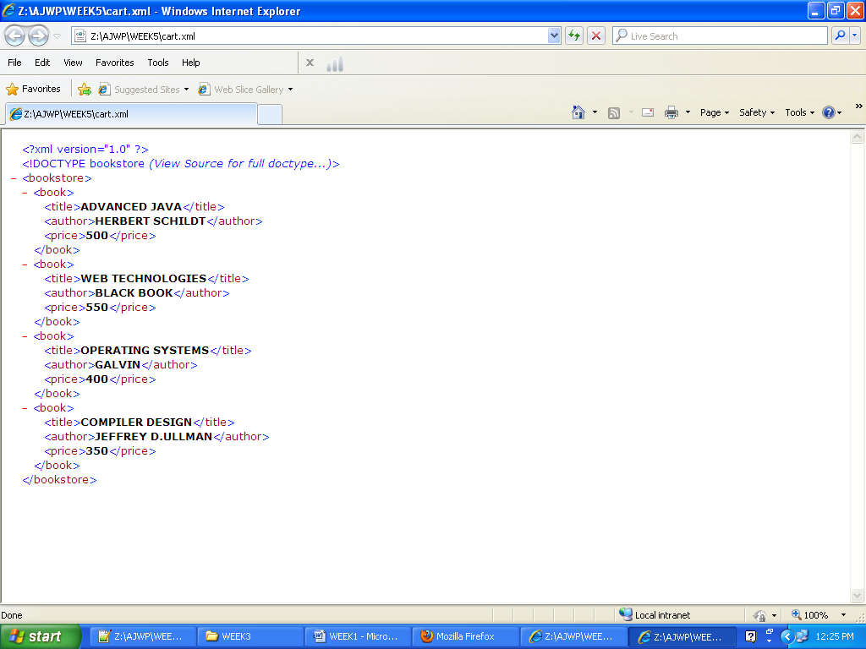

**CART.XML**

<?xml version="1.0"?>

<bookstore xmlns:xsi="http://www.w3.org/2001/XMLSchemaInstance" xsi:noNameSpaceSchema="book.xsd">

<bookstore>

<book>

<title> ADVANCED JAVA </title>

<author> HERBERT SCHILDT </author>

<price> 500 </price>

</book>

<book>

<title> WEB TECHNOLOGIES </title>

<author> BLACK BOOK </author>

<price> 550 </price>

</book>

<book>

<title> OPERATING SYSTEMS </title>

<author> GALVIN </author>

<price> 400 </price>

</book>

<book>

<title> COMPILER DESIGN </title>

<author> JEFFREY D.ULLMAN </author>

<price> 350 </price>

</book>

</bookstore>

**BOOK.XSD**

<?xml version="1.0"?>

<xs:schema xmlns:xs="http://www/w3/org/2001/XMLSchema">

<xs:element name="bookstore">

<xs:ComplexType>

<xs:Sequence>

<xs:element name="book" MinOccurs=4>

<xs:ComplexType>

<xs:Sequence>

<xs:element name="title" type="xs:string" />

<xs:element name="author" type="xs:string" />

<xs:element name="price" type="xs:integer" />

</xs:Sequence>

</xs:ComplexType>

</xs:element>

</xs:Sequence>

</xs:ComplexType>

</xs:element>

</xs:schema>

**Output:**

after execution cart.xml this is output

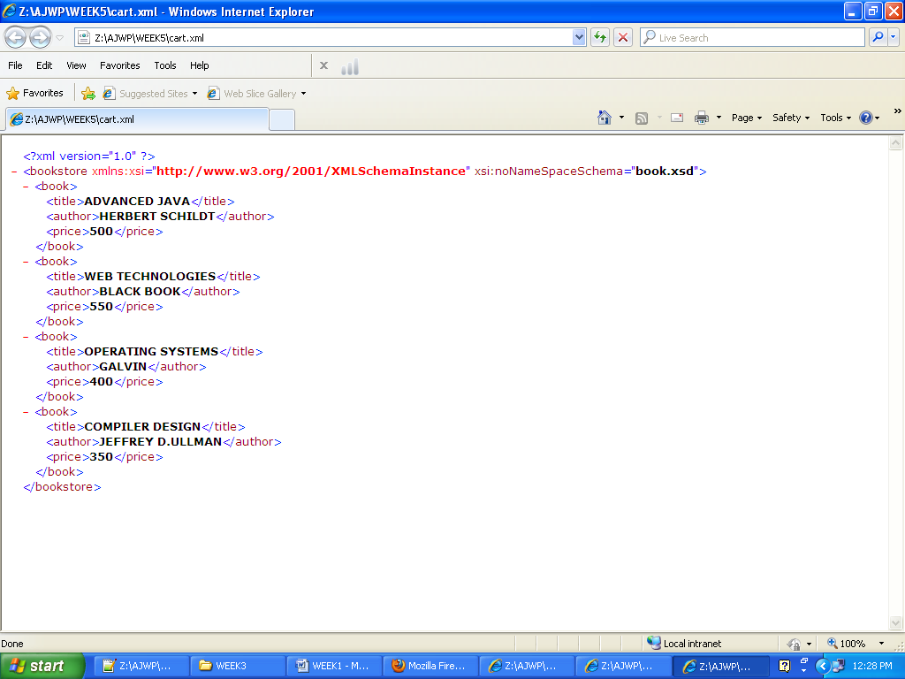

**Output:**

after execution cart.xml this is output

**CART.XML**

<?xml version="1.0"?>

<?xml-stylesheet type="text/xsl" href="book.xsl"?>

<bookstore>

<book>

<title> ADVANCED JAVA </title>

<author> HERBERT SCHILDT </author>

<price> 500 </price>

</book>

<book>

<title> WEB TECHNOLOGIES </title>

<author> BLACK BOOK </author>

<price> 550 </price>

</book>

<book>

<title> OPERATING SYSTEMS </title>

<author> GALVIN </author>

<price> 400 </price>

</book>

<book>

<title> COMPILER DESIGN </title>

<author> JEFFREY D.ULLMAN </author>

<price> 350 </price>

</book>

</bookstore>

**BOOK.XSL**

<?xml version="1.0"?>

<xsl:stylesheet version="1.0" xmlns:xsl="http://www.w3.org/1999/XSL/Transform">

<xsl:template match="/">

<html>

<body>

<h1>Details of bookstore</h1>

<table border="1">

<tr bgcolor="green">

<th> TITLE </th>

<th> AUTHOR</th>

<th> PRICE</th>

</tr>

<xsl:for-each select="bookstore/book">

<tr bgcolor="magenta">

<td><xsl:value-of select="title"/></td>

<td><xsl:value-of select="author"/></td>

<td><xsl:value-of select="price"/></td>

</tr>

</xsl:for-each>

</table>

</body>

</html>

</xsl:template>

</xsl:stylesheet>

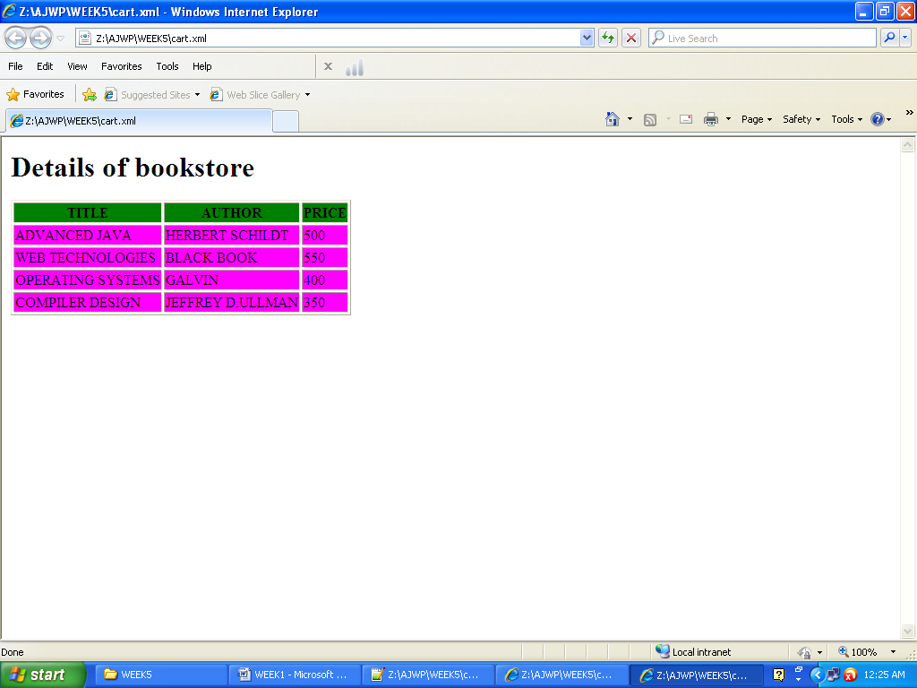

**VIVA QUESTIONS:**

1. What is DTD,XSD,XPATH.
2. What are syntax for elements ,attributes?
3. How to define mixoccurence and max occurrence of elements?
4. How to define empty element in dtd,xsd ?
5. For which purpose we use complex type.

**PROGRAM-7**

**Aim:** Create Web pages using AJAX.

<!DOCTYPE html>

<html>

<body>

<div id="demo">

<h1>The XMLHttpRequest Object</h1>

<button type="button" onclick="loadDoc()">Change Content</button>

</div>

<script>

function loadDoc() {

var xhttp = new XMLHttpRequest();

xhttp.onreadystatechange = function() {

if (this.readyState == 4 && this.status == 200) {

document.getElementById("demo").innerHTML =

this.responseText;

}

};

xhttp.open("GET", "ajax_info.txt", true);

xhttp.send();

}

</script>

</body>

</html>

**Sample Output**:

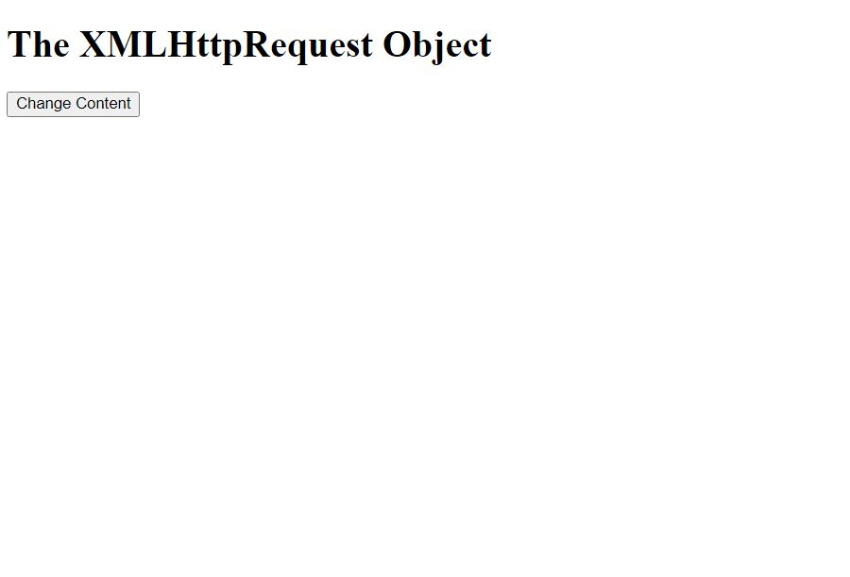

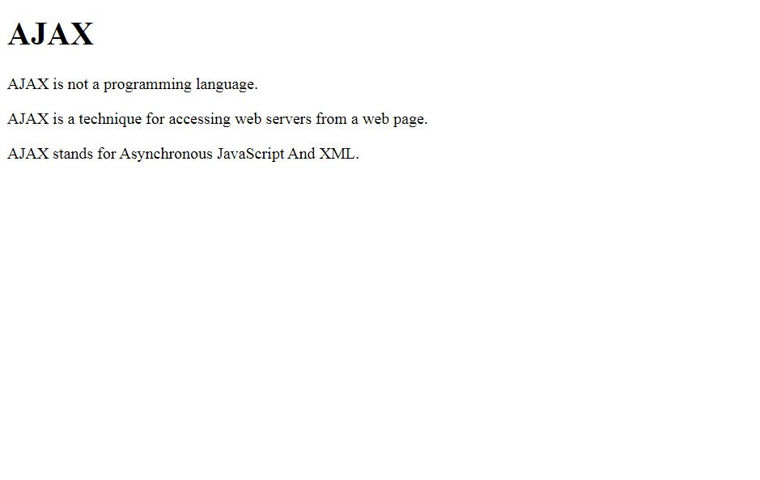

**PROGRAM-8**

**Aim:** User Authentication:

Assume four users user1, user2, user3 and user4 having the passwords pwd1, pwd2, pwd3

and pwd4 respectively. Write a PHP for doing the following.

1. Create a Cookie and add these four user id’s and passwords to this Cookie.

2. Read the user id and passwords entered in the Login form (week1) and authenticate with

the values (user id and passwords) available in the cookies.

If he is a valid user (i.e., user-name and password match) you should welcome him by name

(user-name) else you should display “You are not an authenticated user ’’.

Use init-parameters to do this.

**Description:** Assume four users user1,user2,user3 and user4 having the passwords pwd1,pwd2,pwd3 and pwd4respectively. Write a PHP for doing the following.

1. Create a Cookie and add these four user id’s and passwords to this Cookie.

2. Read the user id and passwords entered in the Login form and authenticate with the values available in the cookies.If he is a valid user and password match you should welcome him by name elseyou should display “ You are not an authenticated user ’’.Use init-parameters to do this.

**Algorithm:**

Step1:start.

Step 2: Save a program with extention.php.

Step 3: create a Cookie and add these four user id’s and passwords to this Cookie.using the setcookie() function setcookie($cookie_user1,$cookie_pass1,time() + (86400 * 30),"/"); // 86400 = 1 day

Step 4:check whether cookies enabled or not using count($_COOKIE) > 0)statements, get the cookie using the statement $_COOKIE["user1"]; check with local variables ,if match found authorized user else not,use loop to check for($j=1;$j<count($_COOKIE);$j++) as well as use the statements if($$k==$passt) for checking right or not..

Step 5:stop.

**Programs Code:**

**Cookieset.php**

<?php

$cookie_user1 = "user1";

$cookie_pass1 = "ram1";

$cookie_user2 = "user2";

$cookie_pass2 = "ram2";

$cookie_user3 = "user3";

$cookie_pass3 = "ram3";

$cookie_user4 = "user4";

$cookie_pass4 = "ram4";

setcookie($cookie_user1,$cookie_pass1,time() + (86400 * 30),"/"); // 86400 = 1 day

setcookie($cookie_user2,$cookie_pass2,time() + (86400 * 30),"/"); // 86400 = 1 day

setcookie($cookie_user3,$cookie_pass3,time() + (86400 * 30),"/"); // 86400 = 1 day

setcookie($cookie_user4,$cookie_pass4, time() + (86400 * 30),"/"); // 86400 = 1 day

echo "cookie **are set";**

**?>**

**Cookie321.php**

<?php

$flag=0;

if ($_SERVER["REQUEST_METHOD"] == "POST")

{

$namet = $_POST["n1"];

$passt = $_POST["n2"];

// $l=echo $namet;

echo $passt;

}

if(count($_COOKIE) > 0)

{//check whether cookies are enabled are not.

echo "Cookies are enabled.";

$pa1=$_COOKIE["user1"];

$pa2=$_COOKIE["user2"];

$pa3=$_COOKIE["user3"];

$pa4=$_COOKIE["user4"];

for($j=1;$j<count($_COOKIE);$j++)

{

$k="pa".(string)$j;

if($$k==$passt)

{

$flag=1;

}

}//for

}

else

{//if count

echo "cookie are disabled";

}

if($flag==1)

echo "<br>authorized person<br>";

else

echo "<br>unauthorized person<br>";

?>

**Cookielogin.html**

<html>

<body>

<form action="cookie321.php" method="post" >

user name <input type="text" name="n1" value=" ">

passs<input type="password" name="n2" value="" />

<input type="submit" value="submit" />

</form>

</body>

</html>

**SAMPLE OUTPUT:**

Click at cookieset.php

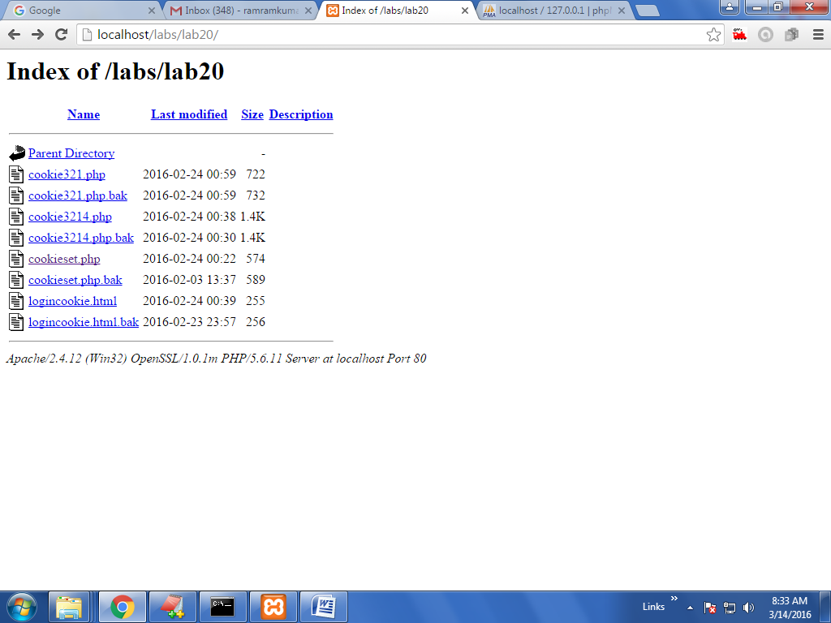

After that below window appears

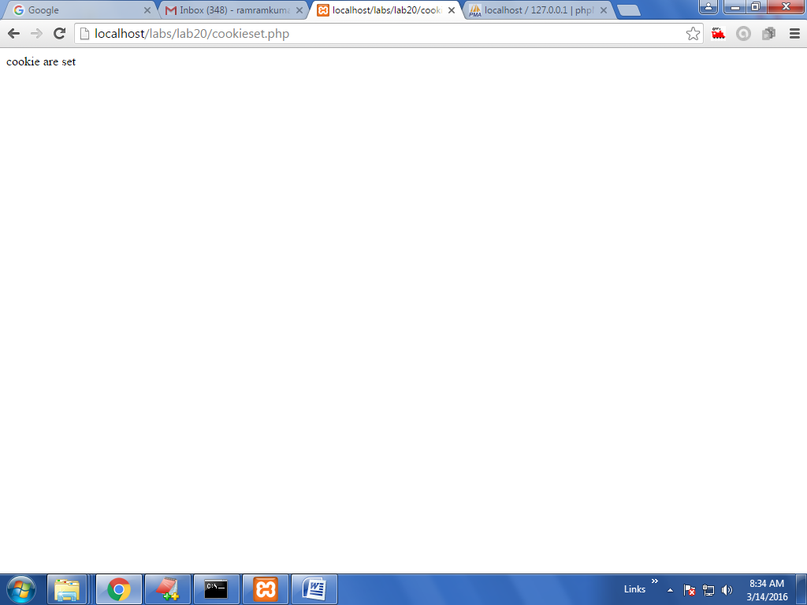

In above window cookies are set. 4 cookies are user1—ram1 ,user2-ram2,user3-ram3, user4---ram4

Then click at logincookie.html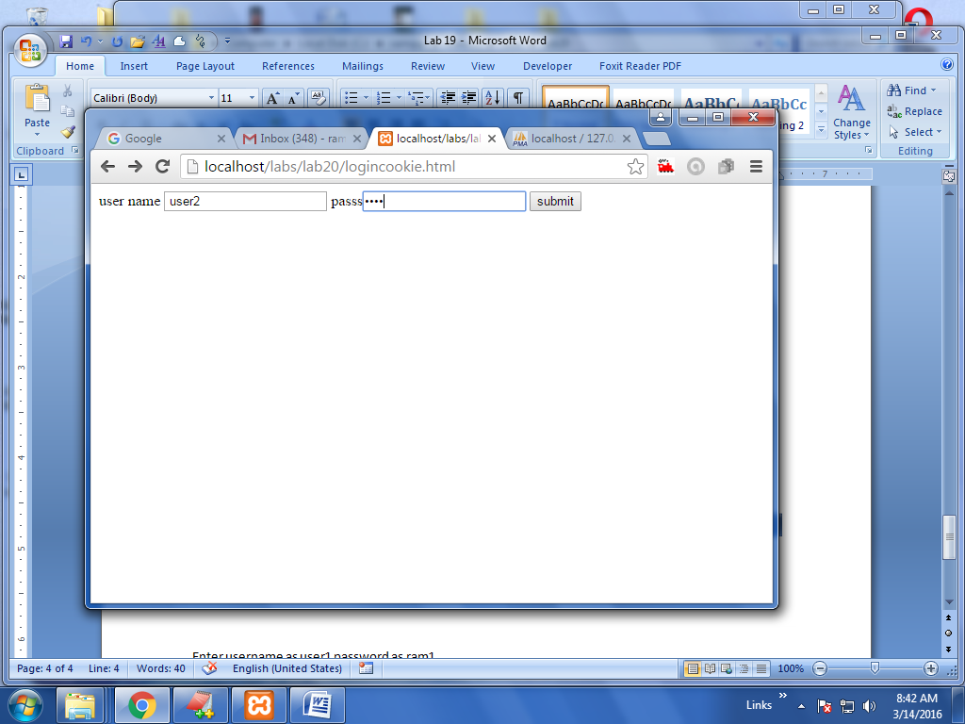

Enter username as user2 password as ram2

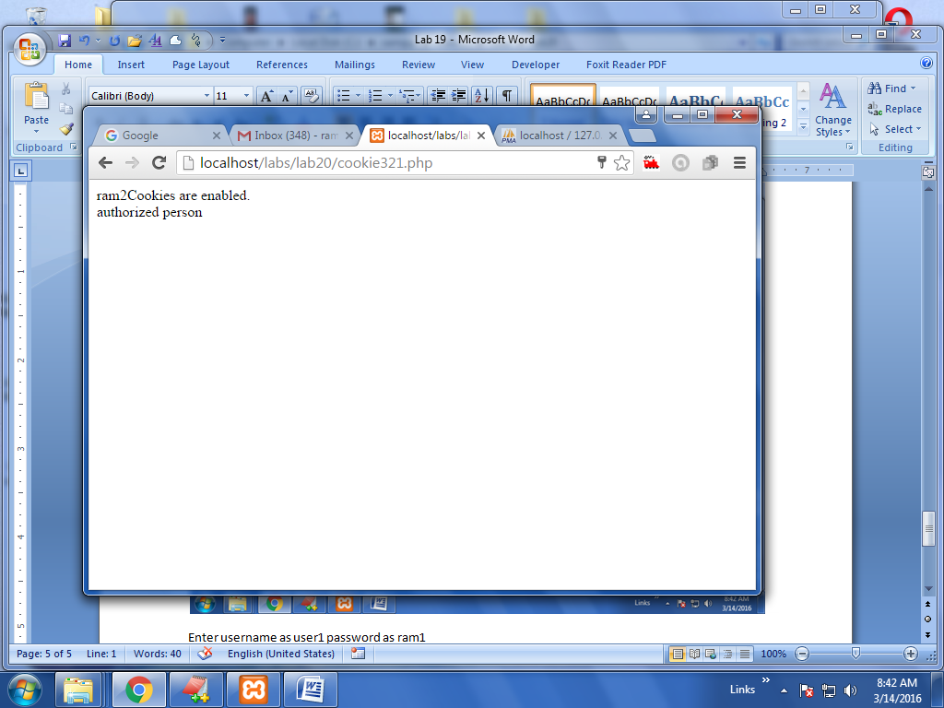

Enter username as hi password as hi (wrong username and passoword)

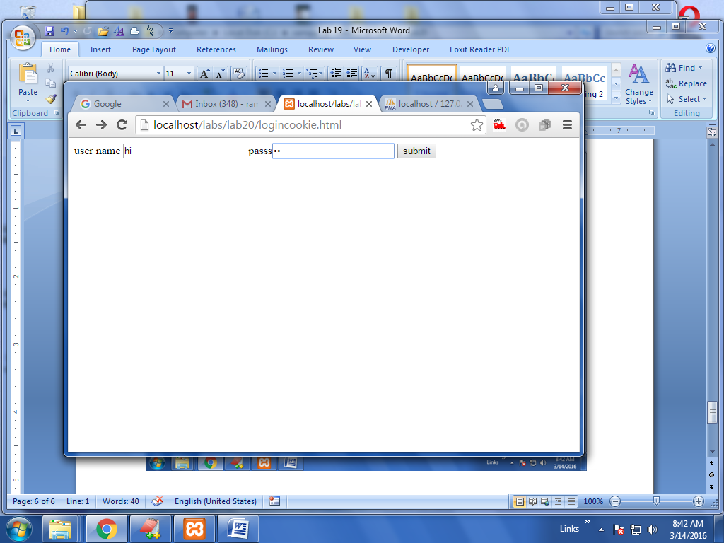

After click at submit

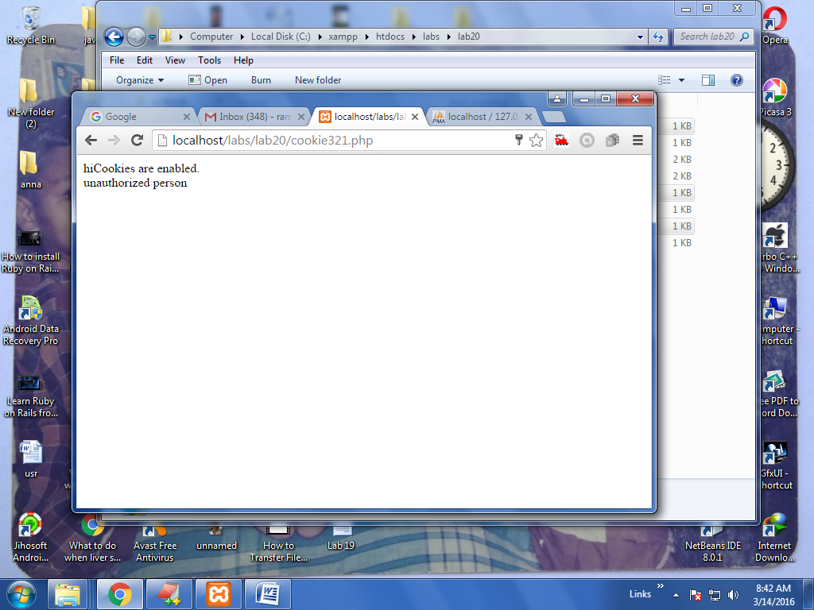

**VIVA QUESTIONS:**

1. What do you mean by having PHP as whitespace insensitive?
2. Is PHP a case sensitive language?
3. What are the characteristics of PHP variables?
4. What are the different types of PHP variables?
5. What are rules for naming a PHP variable?

**PROGRAM-9**

**Aim:** Example PHP program for registering users of a website and login.

**Description:** PHP program for registering users of a website and login.

**Algorithm:**

**Step1**:start.

**Step 2**: Save a program with extention.php. here database is mysql ,username is root with no password. Use the mysql_connect and mysql_query() statements to execute sql statements and retrieve the data using the $row = mysql_fetch_array($retval)

**Step 3**: here create a html page which contains the username and password after submitting it go to the insertdata.php using the $n1=$_POST['n1']; statement we get the value of previous page then using the $sql = "INSERT INTO users"."(name, pass)VALUES('".$n1."','".$n2."')"; statement insert the data in user table.

**Step 4**: using the $sql = 'SELECT * FROM users'; statement we retrieve the list of username and password.

**Step 5**: Stop.

**Program Code**

Click at cookieset.php

**Dataform.html**

<html>

<body>

<form action="insertdata.php" method="post">

Name: <input type="text" name="n1"><br>

password <input type="password" name="n2"><br>

<input type="submit" value="submit" />

</form>

</body>

</html>

**Insertdata.php**

<?php

$dbhost = 'localhost';

$dbuser = 'root';

$dbpass = '';

$conn = mysql_connect($dbhost, $dbuser, $dbpass);

if(! $conn ) {

die('Could not connect: ' . mysql_error());

}

$n1=$_POST['n1'];

$n2=$_POST['n2'];

// $n3=$_GET['n3'];

// $n4=$_GET['n4'];

// $n5=$_GET['n5'];

$sql = "INSERT INTO users"."(name,pass)VALUES('".$n1."','".$n2."')";

mysql_select_db('ram');

$retval = mysql_query( $sql, $conn );

if(! $retval ) {

die('Could not enter data: ' . mysql_error());

}

echo "Entered data successfully\n";

mysql_close($conn);

?>

<html>

<body>

<a href="retrive.php">fetch data </a>

</body>

</html>

**Retrieve.php**

<?php

$dbhost = 'localhost';

$dbuser = 'root';

$dbpass = '';

$conn = mysql_connect($dbhost, $dbuser, $dbpass);

if(! $conn ) {

die('Could not connect: ' . mysql_error());

}

$sql = 'SELECT * FROM users';

mysql_select_db('ram');

$retval = mysql_query( $sql, $conn );

if(! $retval ) {

die('Could not get data: ' . mysql_error());

}

echo "<p style='color:green'> list of registed user and thier passwords</p>";

echo " <p style='color:green'> name &nbsp;&nbsp;"." pass &nbsp;&nbsp; </p>"."<br>";

while($row = mysql_fetch_array($retval))

{

echo $row['name']."&nbsp;&nbsp;";

echo $row['pass']."&nbsp;&nbsp;";

//echo $row['address']."&nbsp;&nbsp;";

// echo $row['phono']."&nbsp;&nbsp;";

// echo $row['email']."&nbsp;&nbsp;";

// echo "EMP ID :{$row['name']}&nbsp;&nbsp; ";

// echo "name :{$row['name']}&nbsp;&nbsp; ";

// echo "address :{$row['name']}&nbsp;&nbsp; ";

// echo "phone no :{$row['name']}&nbsp;&nbsp; ";

// echo "email :{$row['name']}&nbsp;&nbsp; ";

echo"<br>";

// "EMP NAME : {$row['regno']} <br> "."EMP NAME : {$row['address']} <br> "."EMP NAME : {$row['phono']} <br> //"."EMP SALARY : {$row['email']} <br> ". "--------------------------------<br>";

}

echo "Fetched data successfully\n";

mysql_close($conn);

?>

**Create.php**

<?php

$dbhost = 'localhost';

$dbuser = 'root';

$dbpass = '';

$conn = mysql_connect($dbhost, $dbuser, $dbpass);

if(! $conn ) {

die('Could not connect: ' . mysql_error());

}

$sql = "CREATE TABLE users(name varchar(50),pass varchar(50))";

mysql_select_db('ram');

$retval = mysql_query( $sql, $conn );

if(! $retval ) {

die('table not created: ' . mysql_error());

}

echo "table created successfully\n";

mysql_close($conn);

/*CREATE TABLE MyGuests (

id INT(6) UNSIGNED AUTO_INCREMENT PRIMARY KEY,

firstname VARCHAR(30) NOT NULL,

lastname VARCHAR(30) NOT NULL,

email VARCHAR(50),

reg_date TIMESTAMP

)*/

?>

**Testdata2.php**

<?php

$dbhost = 'localhost';

$dbuser = 'root';

$dbpass = '';

$conn = mysql_connect($dbhost, $dbuser, $dbpass);

if(! $conn ) {

die('Could not connect: ' . mysql_error());

}

echo 'Connected successfully';

$sql = 'CREATE Database ram';

$retval = mysql_query( $sql, $conn );

if(! $retval ) {

die('Could not create database: ' . mysql_error());

}

echo "Database test_db created successfully\n";

mysql_close($conn);

?>

**Sample outputs**

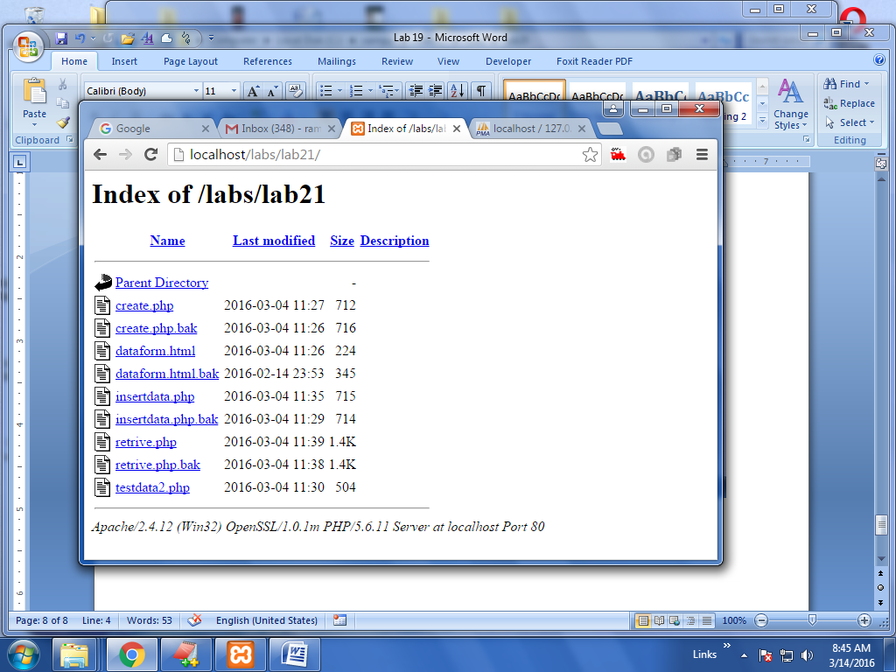

Click at testdata2.php inorder to create the ram database

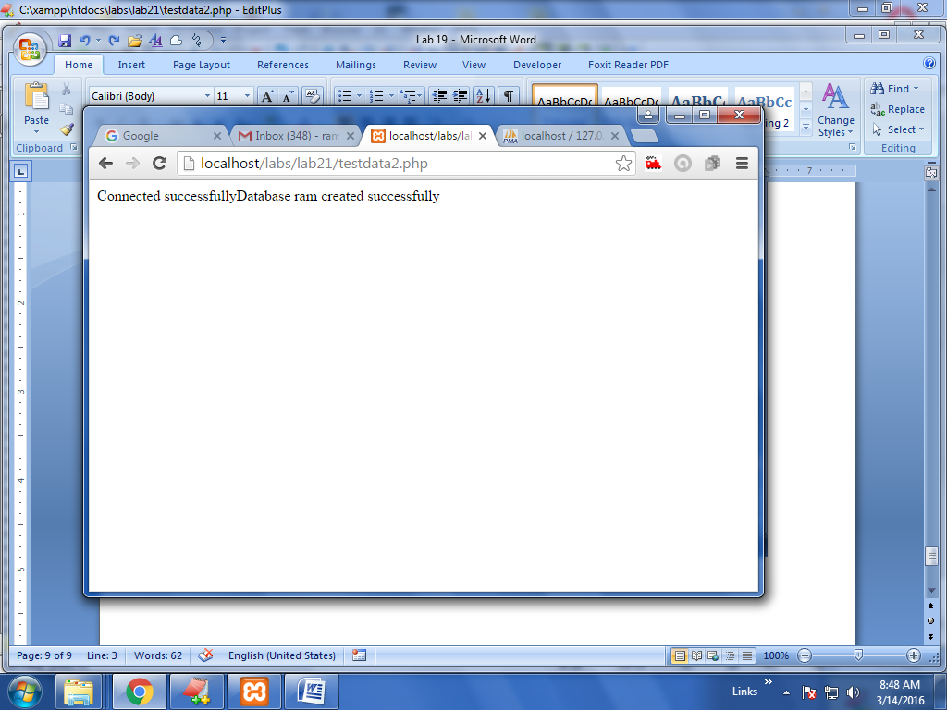

After that create the table called users by click at crate.php

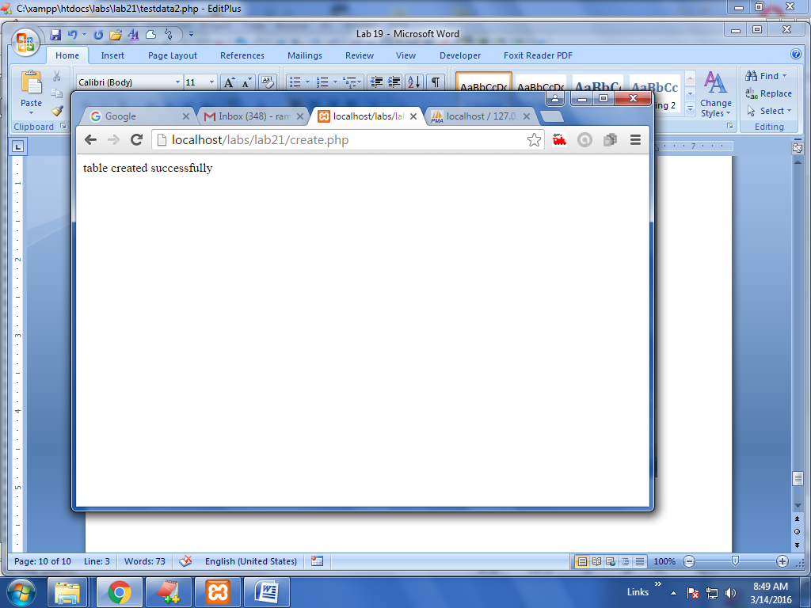

Aferthat click at dateform.html

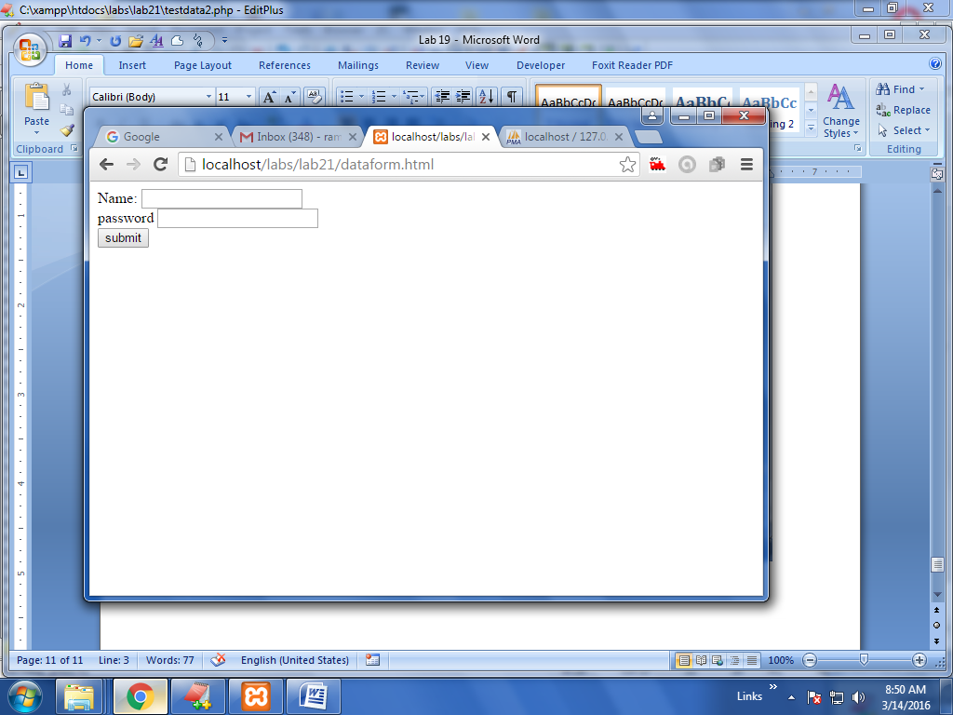

Then enter the user name as ram and password as pass

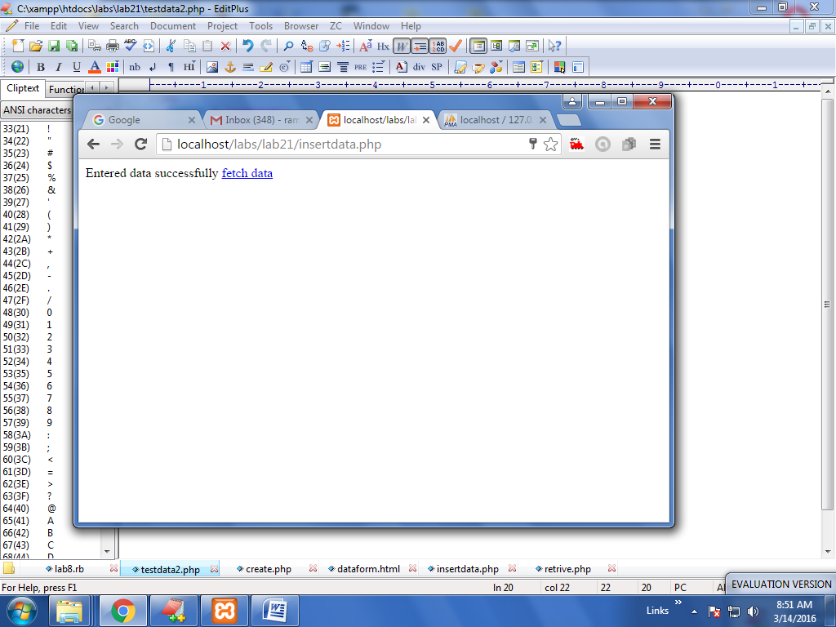

Enter some more data at dataform.html

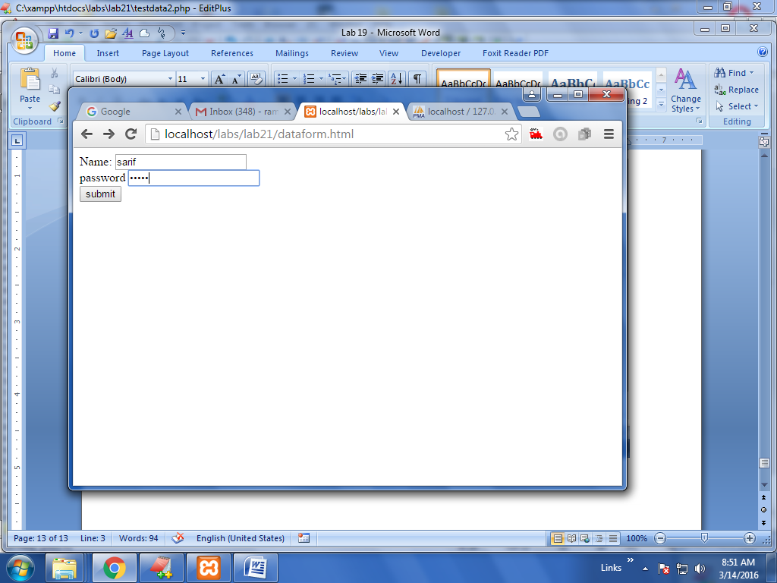

Click at submit

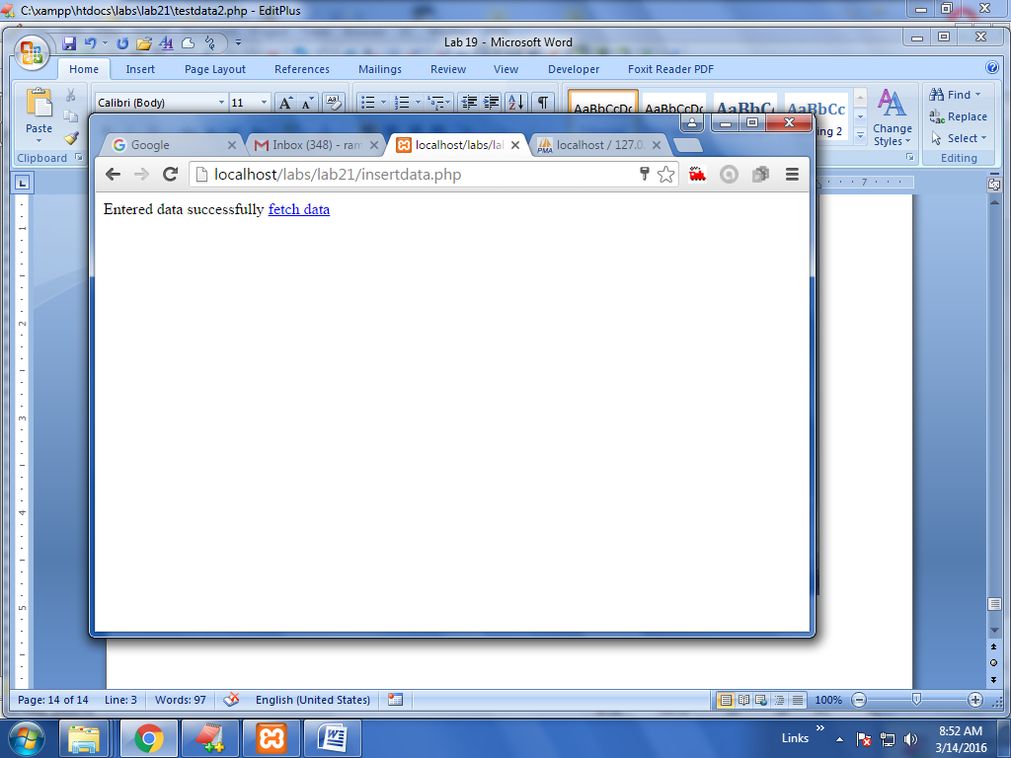

Then click at fetch data text

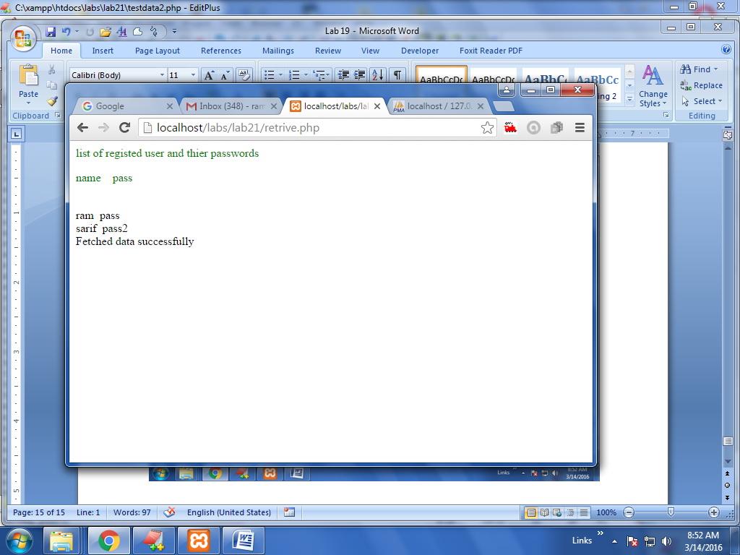

In above we retrieved different users from database successfully .

**VIVA QUESTIONS:**

1. What is the purpose of _LINE_ constant?
2. What is the purpose of _FILE_ constant?
3. What is the purpose of _FUNCTION_ constant?
4. What is the purpose of _CLASS_ constant?
5. What is the purpose of _METHOD_ constant ,explain gloable constants.?

**PROGRAM-10**

**Aim:** Install a database (Mysql or Oracle).

Create a table which should contain at least the following fields: name, password, emailid,

phone number (these should hold the data from the registration form).

Write a PHP program to connect to that database and extract data from the tables and

display them. Experiment with various SQL queries.

Insert the details of the users who register with the web site, whenever a new user clicks

the submit button in the registration page (week2).

**Description:** Install a database(Mysql or Oracle).

Create a table which should contain at least the following fields: name, password, email-id, phone

number(these should hold the data from the registration form).

Write a PHP program to connect to that database and extract data from the tables and display them.Experiment with various SQL queries.Insert the details of the users who register with the web site, whenever a new user clicks the submit button inthe registration page

**Algorithm:**

**Step1**:start.

**Step 2**: Save a program with extention.php.

**Step 3**: Install a database(Mysql or Oracle)

**Step 4**:create a html page which contains the name and password email so on then click submit

**Step 5**: Save a program with extention.php. here database is mysql ,username is root with no password. Use the mysql_connect and mysql_query() statements to execute sql statements and retrieve the data.

**Step6**: after submitting the it go to the insertdata.php using the $n1=$_POST['n1']; statement we get the value of previous page then using the $sql = "INSERT INTO users"."(name,pass etc)VALUES('".$n1."','".$n2."' etc)"; statement insert data into table

**Step 7**:using the $sql = 'SELECT * FROM users'; statement we retrieve the list of username and password and then print in html format.

**Step 8**:stop.

**Programs Code:**

**Create.php**

<?php

$dbhost = 'localhost';

$dbuser = 'root';

$dbpass = '';

$conn = mysql_connect($dbhost, $dbuser, $dbpass);

if(! $conn ) {

die('Could not connect: ' . mysql_error());

}

$sql = "CREATE TABLE hi(name varchar(50),regno varchar(50),address varchar(50), phono varchar(50),email varchar(50))";

mysql_select_db('ram');

$retval = mysql_query( $sql, $conn );

if(! $retval ) {

die('table not created: ' . mysql_error());

}

echo "table created successfully\n";

mysql_close($conn);

/*CREATE TABLE MyGuests (

id INT(6) UNSIGNED AUTO_INCREMENT PRIMARY KEY,

firstname VARCHAR(30) NOT NULL,

lastname VARCHAR(30) NOT NULL,

email VARCHAR(50),

reg_date TIMESTAMP

)*/

?>

**Retrieve .php**

<?php

$dbhost = 'localhost';

$dbuser = 'root';

$dbpass = '';

$conn = mysql_connect($dbhost, $dbuser, $dbpass);

if(! $conn ) {

die('Could not connect: ' . mysql_error());

}

$sql = 'SELECT * FROM hi';

mysql_select_db('ram');

$retval = mysql_query( $sql, $conn );

if(! $retval ) {

die('Could not get data: ' . mysql_error());

}

echo "<h2 style='color:green'> data of student is</h2><br>";

echo " name &nbsp;&nbsp;"." rollno &nbsp;&nbsp;"." address &nbsp;&nbsp;"." phone &nbsp;&nbsp;"." email &nbsp;&nbsp;<br>";

while($row = mysql_fetch_array($retval))

{

echo $row['name']."&nbsp;&nbsp;";

echo $row['regno']."&nbsp;&nbsp;";

echo $row['address']."&nbsp;&nbsp;";

echo $row['phono']."&nbsp;&nbsp;";

echo $row['email']."&nbsp;&nbsp;";

// echo "EMP ID :{$row['name']}&nbsp;&nbsp; ";

// echo "name :{$row['name']}&nbsp;&nbsp; ";

// echo "address :{$row['name']}&nbsp;&nbsp; ";

// echo "phone no :{$row['name']}&nbsp;&nbsp; ";

// echo "email :{$row['name']}&nbsp;&nbsp; ";

echo"<br>";

// "EMP NAME : {$row['regno']} <br> "."EMP NAME : {$row['address']} <br> "."EMP NAME : {$row['phono']} <br> //"."EMP SALARY : {$row['email']} <br> ". "--------------------------------<br>";

}

echo "Fetched data successfully\n";

mysql_close($conn);

?>

**Dataform.html**

<html>

<body>

<form action="insertdata.php" method="get">

Name: <input type="text" name="n1"><br>

roll <input type="text" name="n2"><br>

address <input type="text" name="n3" /><br>

phone <input type="text" name="n4" /><br>

email <input type="email" name="n5"><br>

<input type="submit" value="submit" />

</form>

</body>

</html>

**Insertdata.php**

<?php

$dbhost = 'localhost';

$dbuser = 'root';

$dbpass = '';

$conn = mysql_connect($dbhost, $dbuser, $dbpass);

if(! $conn ) {

die('Could not connect: ' . mysql_error());

}

$n1=$_GET['n1'];

$n2=$_GET['n2'];

$n3=$_GET['n3'];

$n4=$_GET['n4'];

$n5=$_GET['n5'];

$sql = "INSERT INTO hi"."(name,regno, address, phono,email)VALUES('".$n1."','".$n2."','".$n3."','".$n4."','".$n5."')";

mysql_select_db('ram');

$retval = mysql_query( $sql, $conn );

if(! $retval ) {

die('Could not enter data: ' . mysql_error());

}

echo "Entered data successfully\n";

mysql_close($conn);

?>

<html>

<body>

<a href="retrive.php">fetch data </a>

</body>

</html>

**Sample OUTPUT**

Here already we have created the database called ram no need to go for testdata2.php. if not create go for testdata2.php

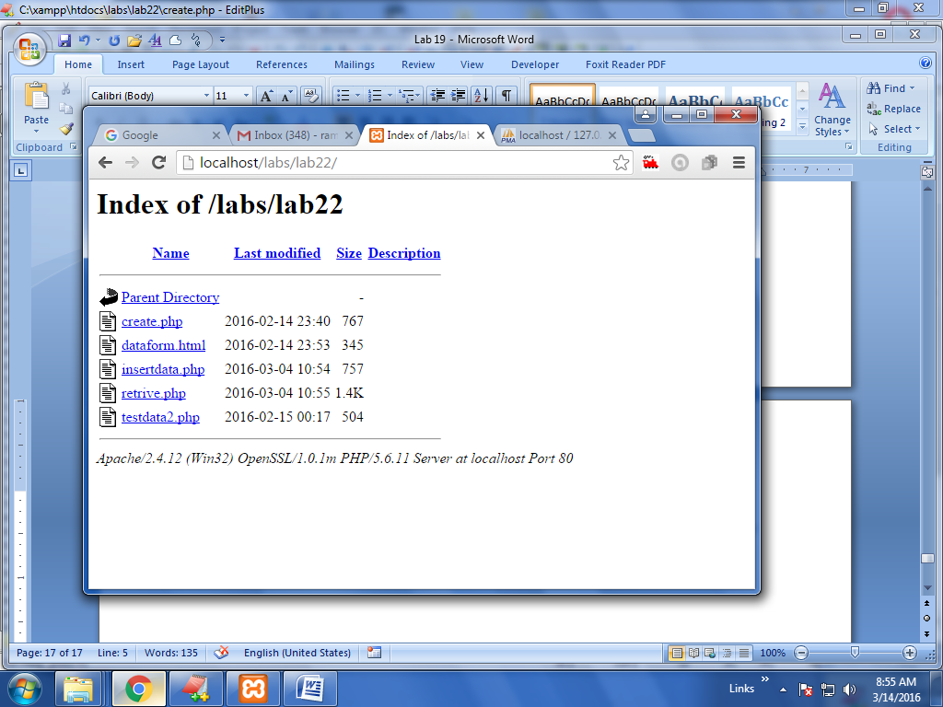

In above click at crate.php it will create a table called hi in the ram database.

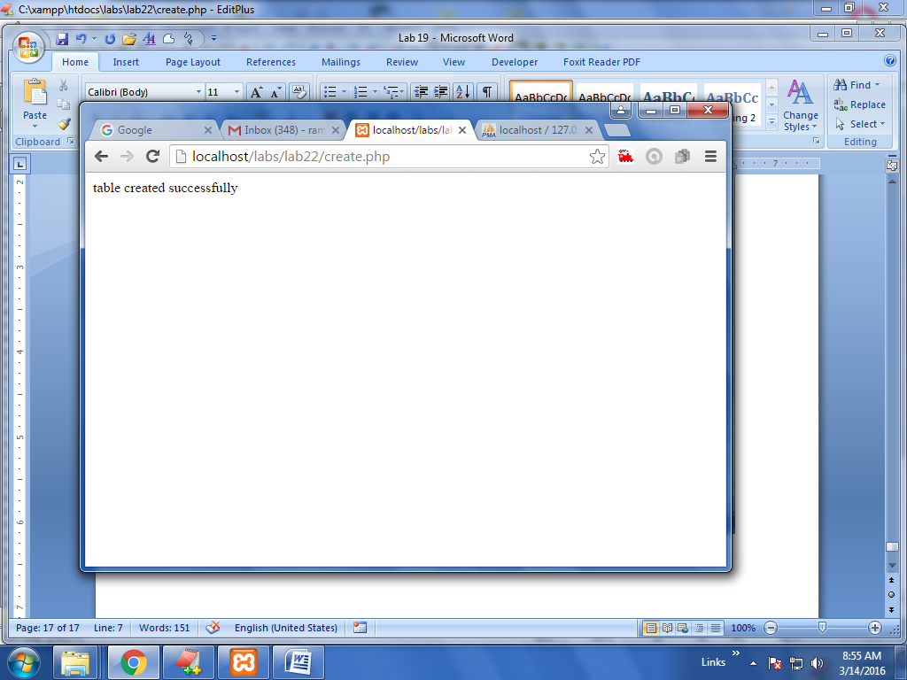

Hi table is created then click at dataform.html

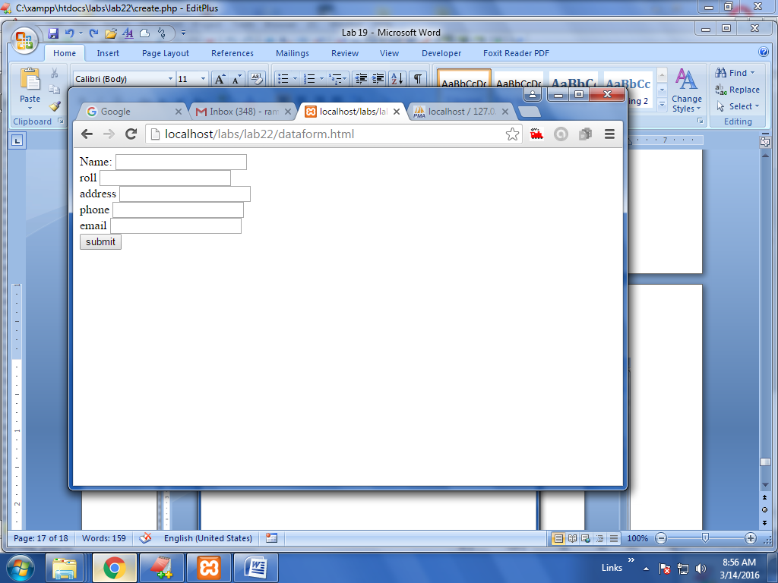

After entering the data

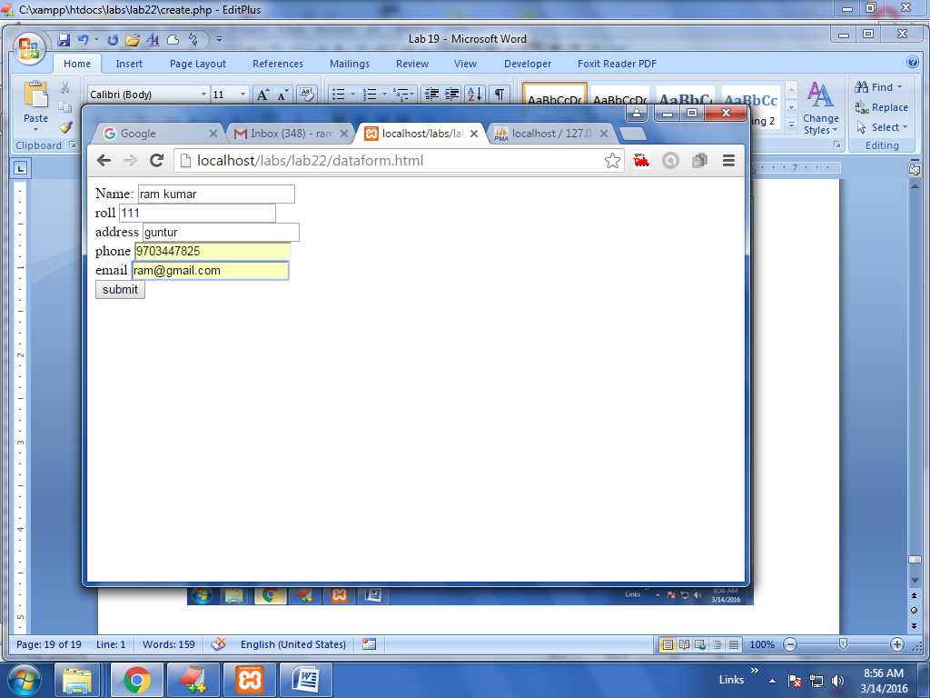

Click submit

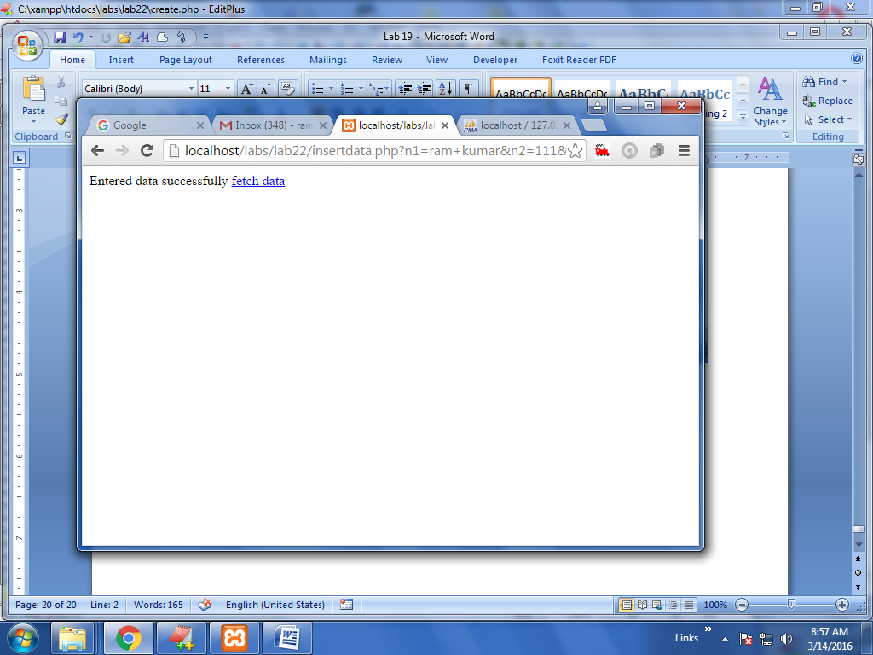

Enter some more data

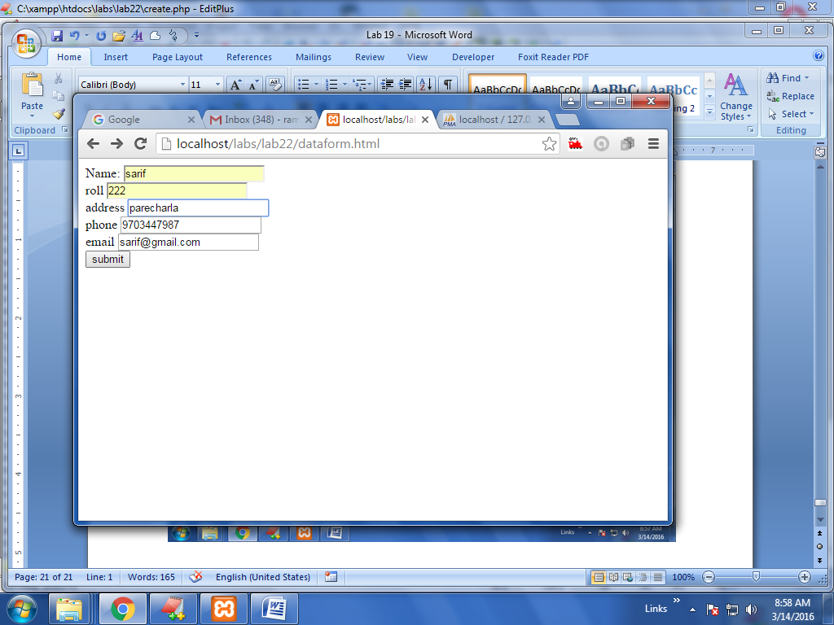

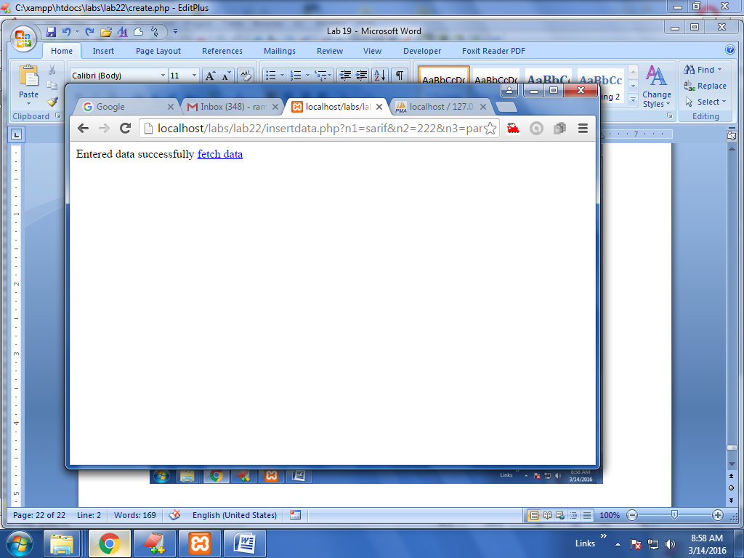

Click at fetchdata text

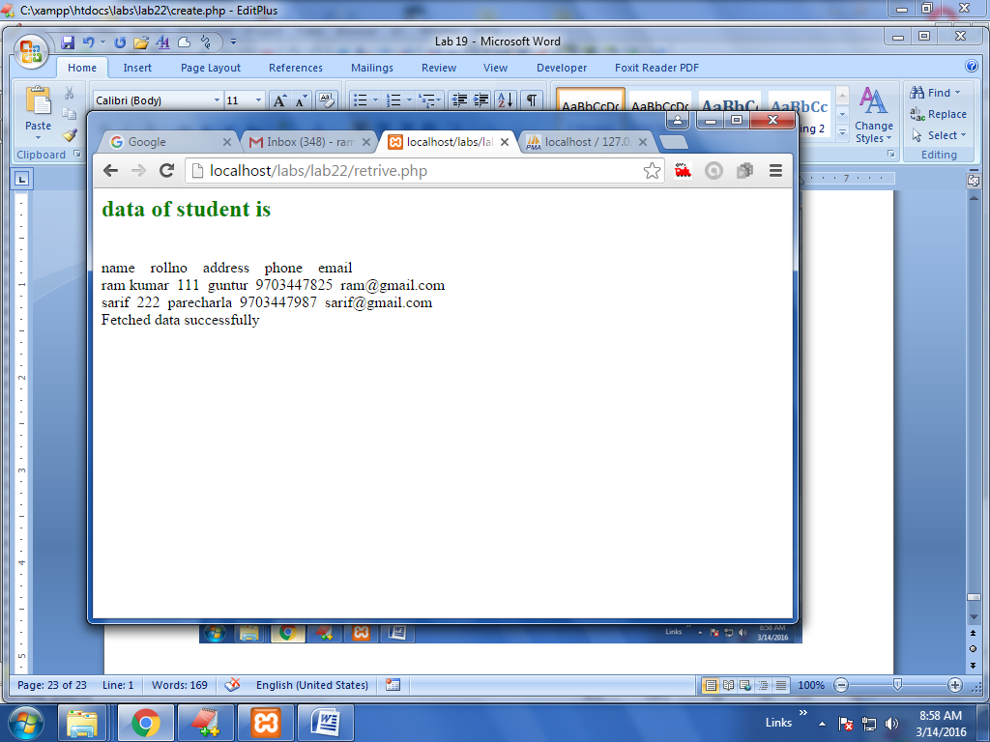

**VIVA QUESTIONS:**

1. How will you set cookies using PHP?
2. How will you get cookies using PHP?
3. How will you make a check that a cookie is set or not?
4. How will you delete a cookie?
5. How will you start a session in PHP?

**PROGRAM-11**

**Aim:** Write a PHP which does the following job:

Insert the details of the 3 or 4 users who register with the web site (week9) by using registration form. Authenticate the user when he submits the login form using the user

name and password from the database (similar to week8 instead of cookies).

**Description:** Insert the details of the 3 or 4 users who register with the web site by using registration form.Authenticate the user when he submits the login form using the user name and password from the database

**Algorithm:**

**Step1**:start.

**Step 2:** Save a program with extention.php.

**Step 3**: Insert the details of the 3 or 4 users who register with the web site by using registration form.

**Step 4**:**like cookies here used the database** Save a program with extention.php. here database is mysql ,username is root with no password. Use the mysql_connect and mysql_query() statements to execute sql statements and retrieve the data.

**Step 5**:here create a html page which contains the username and password after submitting the it go to the insertdata.php using the $n1=$_POST['n1']; statement we get the value of previous page then using the $sql = "INSERT INTO users"."(name,pass)VALUES('".$n1."','".$n2."')"; statement inser the data in user tables

**Step 6**:using the $sql = 'SELECT * FROM users'; statement we retrieve the list of username and password

**Step 7**:stop.

**Programs Code:**

**Vali.html**

<html>

<body>

<form action="auth.php" method="post">

Name: <input type="text" name="n1"><br>

password <input type="password" name="n2"><br>

<input type="submit" value="submit" />

</form>

</body>

</html

**Auth.php**

<?php

$dbhost = 'localhost';

$dbuser = 'root';

$dbpass = '';

$n1=$_POST['n1'];

$n2=$_POST['n2'];

$flag=0;

$conn = mysql_connect($dbhost, $dbuser, $dbpass);

if(! $conn ) {

die('Could not connect: ' . mysql_error());

}

$sql = 'SELECT * FROM users';

mysql_select_db('ram');

$retval = mysql_query( $sql, $conn );

if(! $retval ) {

die('Could not get data: ' . mysql_error());

}

echo "<p style='color:green'> list of registed user and thier passwords</p>";

echo " <p style='color:green'> name &nbsp;&nbsp;"." pass &nbsp;&nbsp; </p>"."<br>";

while($row = mysql_fetch_array($retval))

{

echo $row['name']."&nbsp;&nbsp;";

echo $row['pass']."&nbsp;&nbsp;";

if($row['name']==$n1)

{

if($row['pass']==$n2)

{

$flag=1;

}

}

//echo $row['address']."&nbsp;&nbsp;";

// echo $row['phono']."&nbsp;&nbsp;";

// echo $row['email']."&nbsp;&nbsp;";

// echo "EMP ID :{$row['name']}&nbsp;&nbsp; ";

// echo "name :{$row['name']}&nbsp;&nbsp; ";

// echo "address :{$row['name']}&nbsp;&nbsp; ";

// echo "phone no :{$row['name']}&nbsp;&nbsp; ";

// echo "email :{$row['name']}&nbsp;&nbsp; ";

echo"<br>";

// "EMP NAME : {$row['regno']} <br> "."EMP NAME : {$row['address']} <br> "."EMP NAME : {$row['phono']} <br> //"."EMP SALARY : {$row['email']} <br> ". "--------------------------------<br>";

}

if($flag==1)

echo "<br>authorized person<br>";

else

echo "<br>unauthorized person<br>";

//echo "Fetched data successfully\n";

mysql_close($conn);

?>

Create.php

<?php

$dbhost = 'localhost';

$dbuser = 'root';

$dbpass = '';

$conn = mysql_connect($dbhost, $dbuser, $dbpass);

if(! $conn ) {

die('Could not connect: ' . mysql_error());

}

$sql = "CREATE TABLE users(name varchar(50),pass varchar(50))";

mysql_select_db('ram');

$retval = mysql_query( $sql, $conn );

if(! $retval ) {

die('table not created: ' . mysql_error());

}

echo "table created successfully\n";

mysql_close($conn);

/*CREATE TABLE MyGuests (

id INT(6) UNSIGNED AUTO_INCREMENT PRIMARY KEY,

firstname VARCHAR(30) NOT NULL,

lastname VARCHAR(30) NOT NULL,

email VARCHAR(50),

reg_date TIMESTAMP

)*/

?>

**Dataform.html**

<html>

<body>

<form action="insertdata.php" method="post">

Name: <input type="text" name="n1"><br>

password <input type="password" name="n2"><br>

<input type="submit" value="submit" />

</form>

</body>

</html>

**Insertdata.php**

<?php

$dbhost = 'localhost';

$dbuser = 'root';

$dbpass = '';

$conn = mysql_connect($dbhost, $dbuser, $dbpass);

if(! $conn ) {

die('Could not connect: ' . mysql_error());

}

$n1=$_POST['n1'];

$n2=$_POST['n2'];

// $n3=$_GET['n3'];

// $n4=$_GET['n4'];

// $n5=$_GET['n5'];

$sql = "INSERT INTO users"."(name,pass)VALUES('".$n1."','".$n2."')";

mysql_select_db('ram');

$retval = mysql_query( $sql, $conn );

if(! $retval ) {

die('Could not enter data: ' . mysql_error());

}

echo "Entered data successfully\n";

mysql_close($conn);

?>

<html>

<body>

<a href="retrive.php">fetch data </a>

</body>

</html>

**Retrieve.php**

<?php

$dbhost = 'localhost';

$dbuser = 'root';

$dbpass = '';

$conn = mysql_connect($dbhost, $dbuser, $dbpass);

if(! $conn ) {

die('Could not connect: ' . mysql_error());

}

$sql = 'SELECT * FROM users';

mysql_select_db('ram');

$retval = mysql_query( $sql, $conn );

if(! $retval ) {

die('Could not get data: ' . mysql_error());

}

echo "<p style='color:green'> list of registed user and thier passwords</p>";

echo " <p style='color:green'> name &nbsp;&nbsp;"." pass &nbsp;&nbsp; </p>"."<br>";

while($row = mysql_fetch_array($retval))

{

echo $row['name']."&nbsp;&nbsp;";

echo $row['pass']."&nbsp;&nbsp;";

//echo $row['address']."&nbsp;&nbsp;";

// echo $row['phono']."&nbsp;&nbsp;";

// echo $row['email']."&nbsp;&nbsp;";

// echo "EMP ID :{$row['name']}&nbsp;&nbsp; ";

// echo "name :{$row['name']}&nbsp;&nbsp; ";

// echo "address :{$row['name']}&nbsp;&nbsp; ";

// echo "phone no :{$row['name']}&nbsp;&nbsp; ";

// echo "email :{$row['name']}&nbsp;&nbsp; ";

echo"<br>";

// "EMP NAME : {$row['regno']} <br> "."EMP NAME : {$row['address']} <br> "."EMP NAME : {$row['phono']} <br> //"."EMP SALARY : {$row['email']} <br> ". "--------------------------------<br>";

}

echo "Fetched data successfully\n";

mysql_close($conn);

?>

**Sample Output**

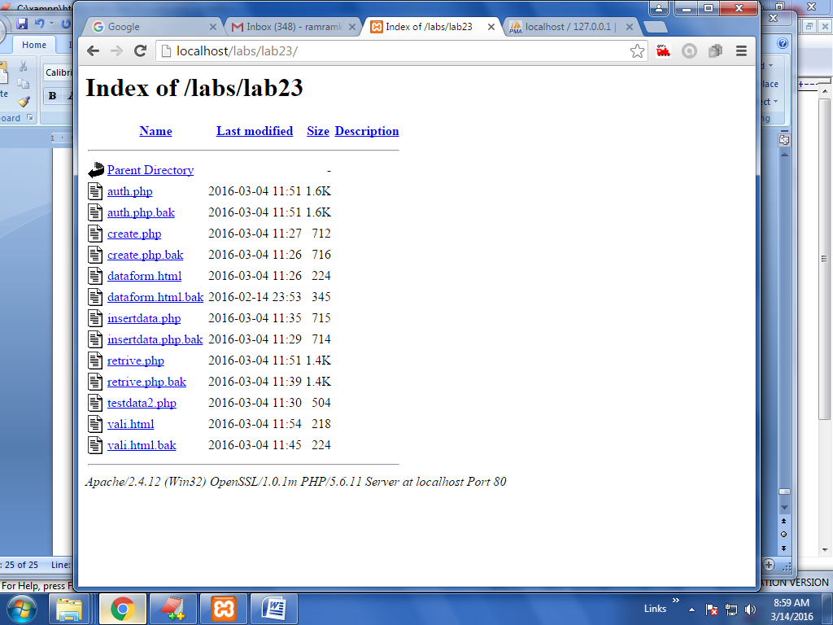

Here no need to create database ram , and no need to create table users because already created.

See the data of users table click at retrieve.php

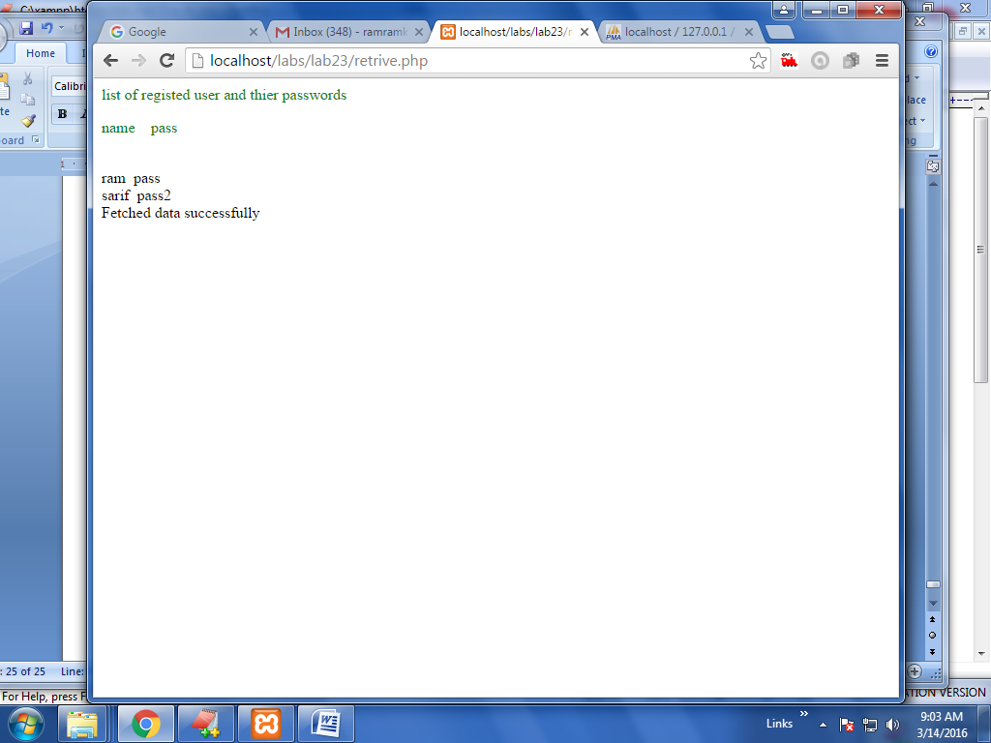

Enter some more data

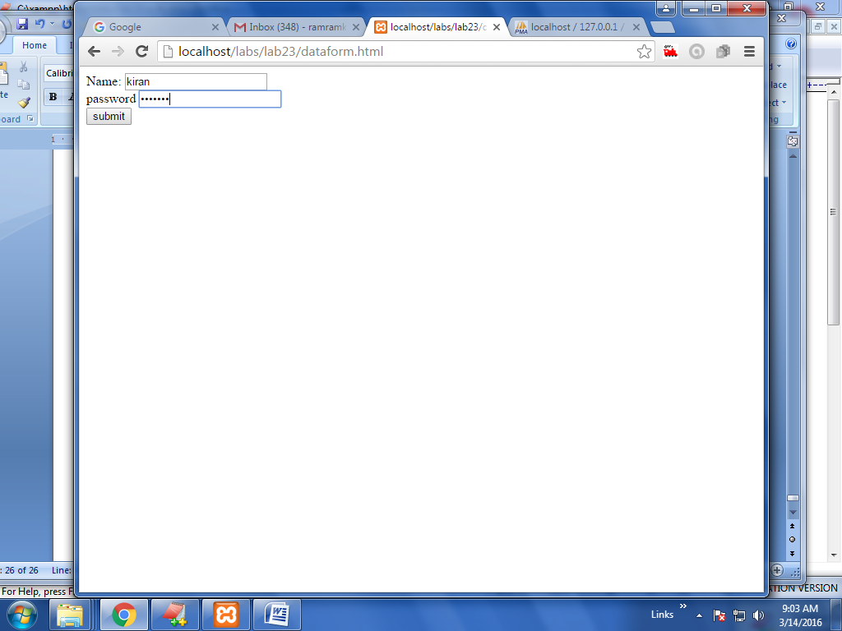

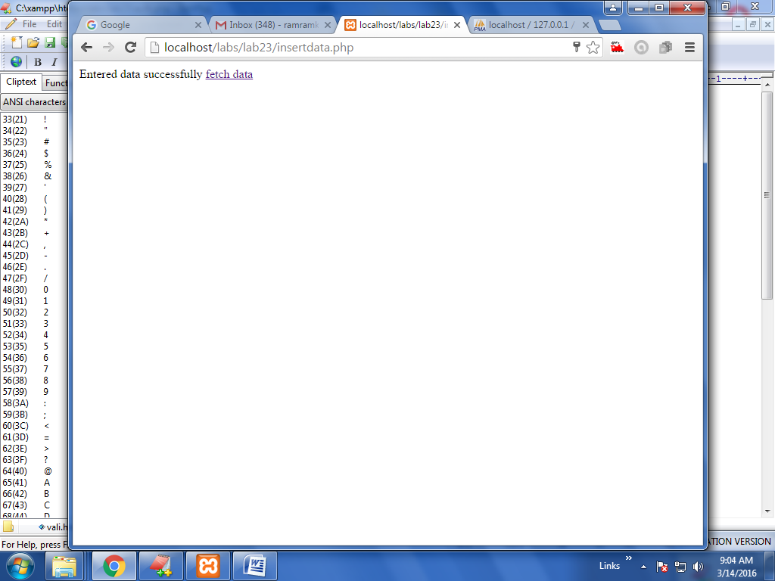

Then click at fetch data text

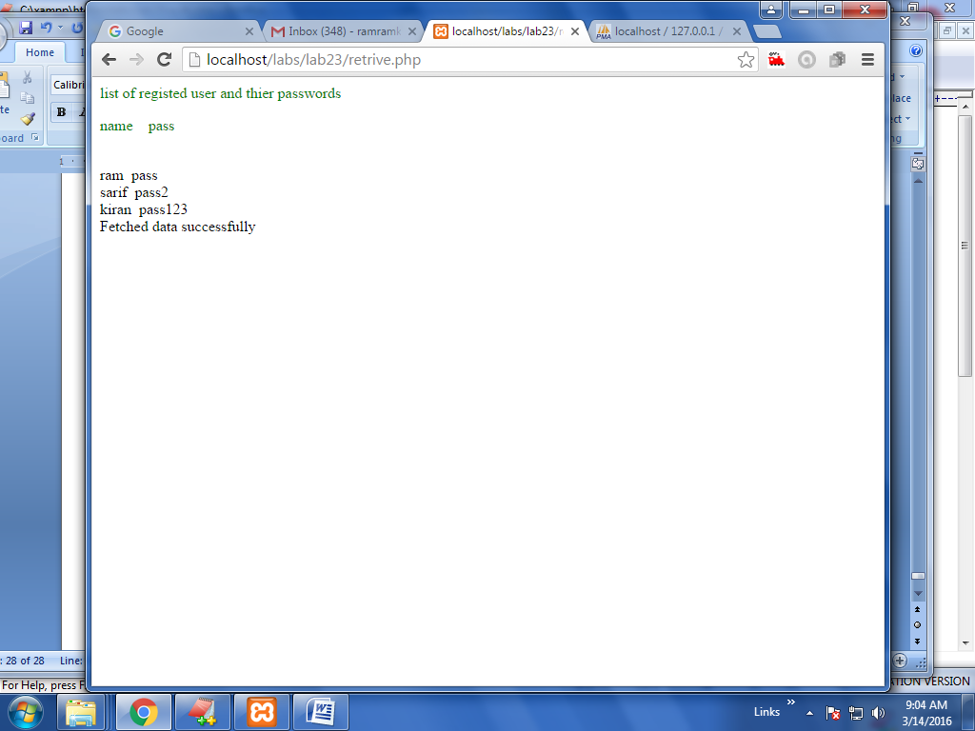

Then go to vali.html

Username as ram and password as pass then click submit

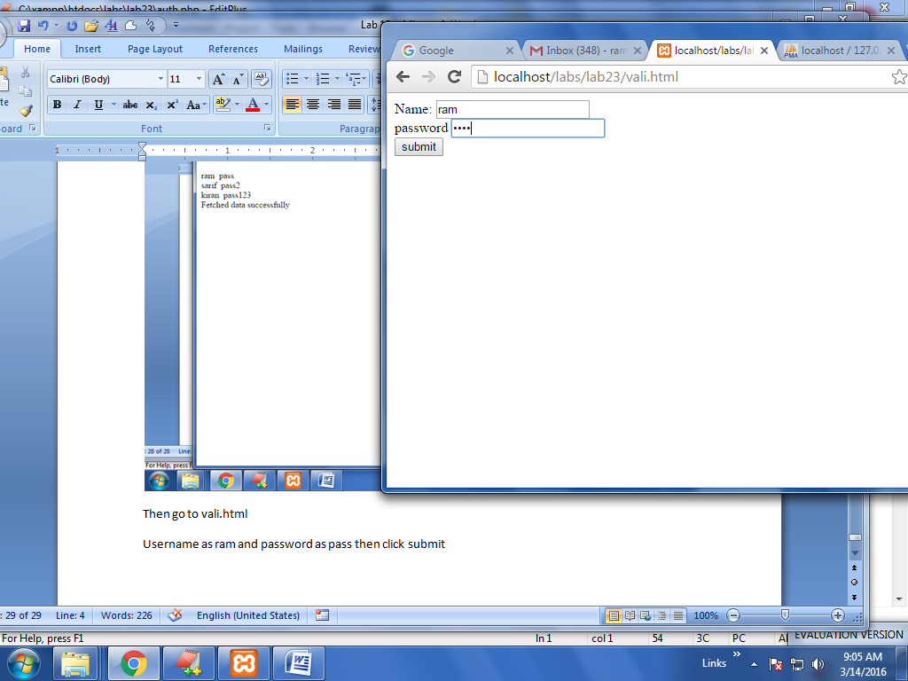

Then submit

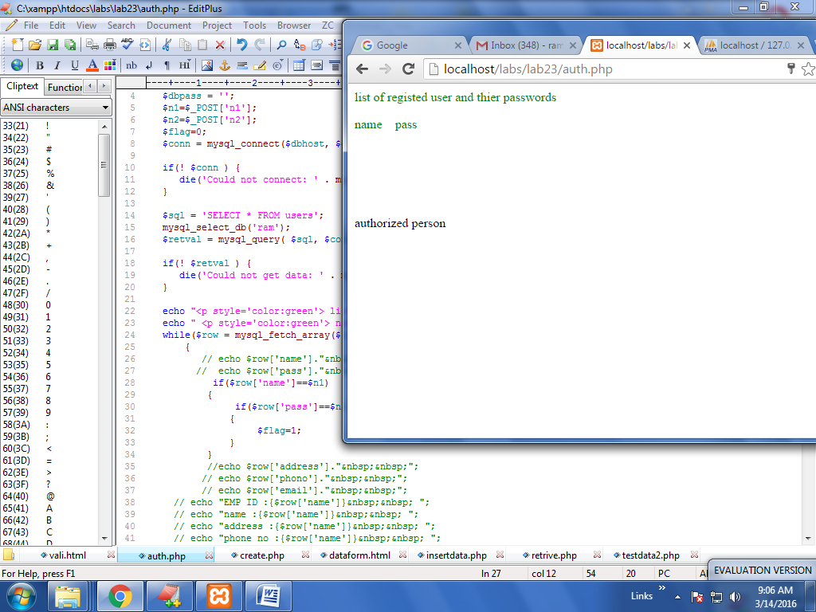

Give like below username as rames and password ttt

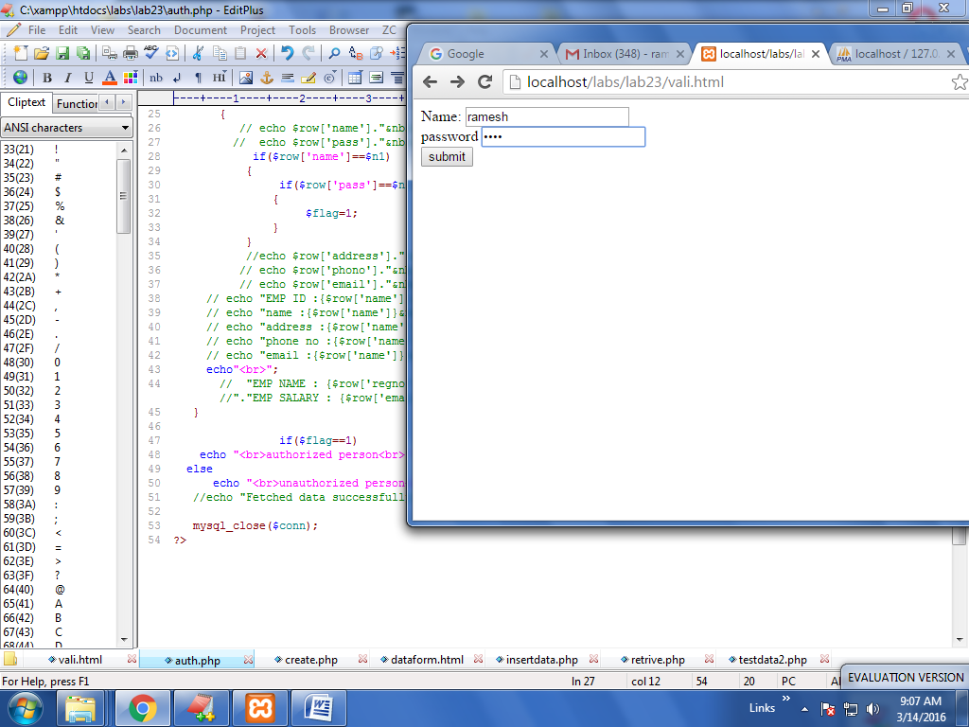

Then submit

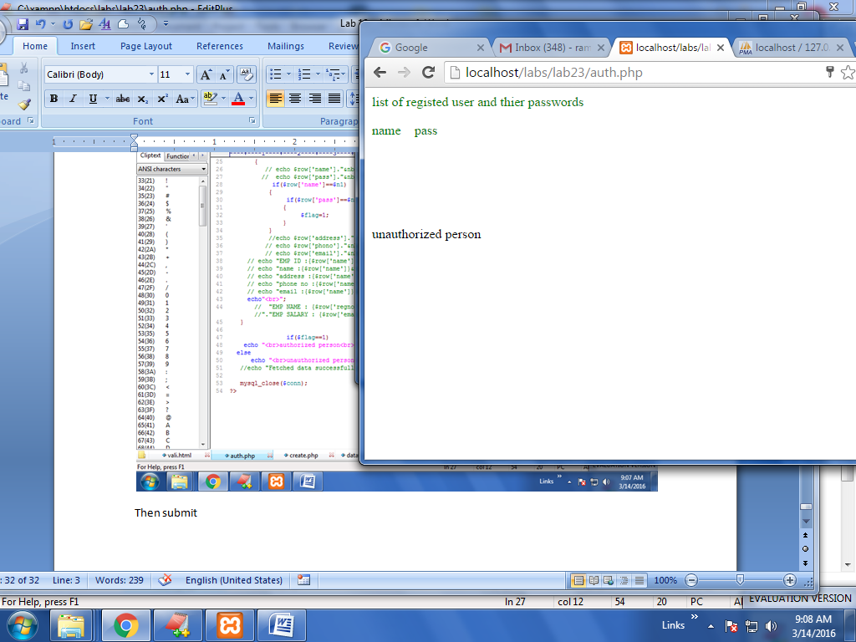

**VIVA QUESTIONS:**

1. How will you destroy the session?
2. How will you send an email using PHP?
3. What is the purpose of $_FILES variable in PHP?
4. How will you access the uploaded file in PHP?
5. How will you access the size of the uploaded file in PHP?

**PROGRAM-12**

**Aim:** Implement a Servlet program on request response processing.

There are given 6 steps to create a **servlet example**. These steps are required for all the servers.

The servlet example can be created by three ways:

1. By implementing Servlet interface,
2. By inheriting GenericServlet class, (or)
3. By inheriting HttpServlet class

The mostly used approach is by extending HttpServlet because it provides http request specific method such as doGet(), doPost(), doHead() etc.

Here, we are going to use **apache tomcat server** in this example. The steps are as follows:

1. Create a directory structure
2. Create a Servlet
3. Compile the Servlet
4. Create a deployment descriptor
5. Start the server and deploy the project
6. Access the servlet

### 1) Create a directory structures

The **directory structure** defines that where to put the different types of files so that web container may get the information and respond to the client.

The Sun Microsystem defines a unique standard to be followed by all the server vendors. Let's see the directory structure that must be followed to create the servlet.

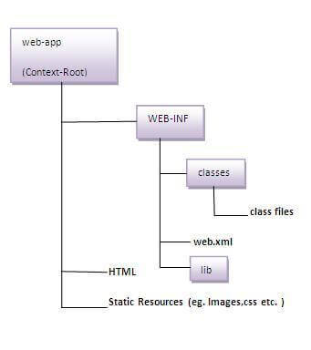

As you can see that the servlet class file must be in the classes folder. The web.xml file must be under the WEB-INF folder.

### 2)Create a Servlet

|  |
| --- |
| There are three ways to create the servlet.   1. By implementing the Servlet interface 2. By inheriting the GenericServlet class 3. By inheriting the HttpServlet class   The HttpServlet class is widely used to create the servlet because it provides methods to handle http requests  such as doGet(), doPost, doHead() etc. |
| In this example we are going to create a servlet that extends the HttpServlet class. In this example, we are  inheriting the HttpServlet class and providing the implementation of the doGet() method. Notice that get  request is the default request. |

**DemoServlet.java**

**import** javax.servlet.http.*;

**import** javax.servlet.*;

**import** java.io.*;

**public** **class** DemoServlet **extends** HttpServlet{

**public** **void** doGet(HttpServletRequest req,HttpServletResponse res)

**throws** ServletException,IOException

{

res.setContentType("text/html");//setting the content type

PrintWriter pw=res.getWriter();//get the stream to write the data

 //writing html in the stream

pw.println("<html><body>");

pw.println("Welcome to servlet");

pw.println("</body></html>");

  pw.close();//closing the stream

}}

### 3)Compile the servlet

|  |  |
| --- | --- |
| **Jar file** | **Server** |
| 1) servlet-api.jar | Apache Tomcat |
| 2) weblogic.jar | Weblogic |
| 3) javaee.jar | Glassfish |
| 4) javaee.jar | JBoss |

For compiling the Servlet, jar file is required to be loaded. Different Servers provide different jar files:

### Two ways to load the jar file

1. set classpath
2. paste the jar file in JRE/lib/ext folder

Put the java file in any folder. After compiling the java file, paste the class file of servlet in **WEB-INF/classes** directory.

### 4) Create the deployment descriptor (web.xml file)

The **deployment descriptor** is an xml file, from which Web Container gets the information about the servet to be invoked.

The web container uses the Parser to get the information from the web.xml file. There are many xml parsers such as SAX, DOM and Pull.

There are many elements in the web.xml file. Here is given some necessary elements to run the simple servlet program.

**web.xml file**

**<web-app>**

**<servlet>**

**<servlet-name>**sonoojaiswal**</servlet-name>**

**<servlet-class>**DemoServlet**</servlet-class>**

**</servlet>**

**<servlet-mapping>**

**<servlet-name>**sonoojaiswal**</servlet-name>**

**<url-pattern>**/welcome**</url-pattern>**

**</servlet-mapping>**

**</web-app>**

### Description of the elements of web.xml file

There are too many elements in the web.xml file. Here is the illustration of some elements that is used in the above web.xml file. The elements are as follows:

|  |
| --- |
| **<web-app>** represents the whole application. |
| **<servlet>** is sub element of <web-app> and represents the servlet. |
| **<servlet-name>** is sub element of <servlet> represents the name of the servlet. |
| **<servlet-class>** is sub element of <servlet> represents the class of the servlet. |
| **<servlet-mapping>** is sub element of <web-app>. It is used to map the servlet. |
| **<url-pattern>** is sub element of <servlet-mapping>. This pattern is used at client side to invoke the servlet. |

### 5)Start the Server and deploy the project

To start Apache Tomcat server, double click on the startup.bat file under apache-tomcat/bin directory.

### One Time Configuration for Apache Tomcat Server

You need to perform 2 tasks:

1. set JAVA_HOME or JRE_HOME in environment variable (It is required to start server).
2. Change the port number of tomcat (optional). It is required if another server is running on same port (8080).

#### 1) How to set JAVA_HOME in environment variable?

To start Apache Tomcat server JAVA_HOME and JRE_HOME must be set in Environment variables.

Go to My Computer properties -> Click on advanced tab then environment variables -> Click on the new tab of user variable -> Write JAVA_HOME in variable name and paste the path of jdk folder in variable value -> ok -> ok -> ok.

Go to My Computer properties:

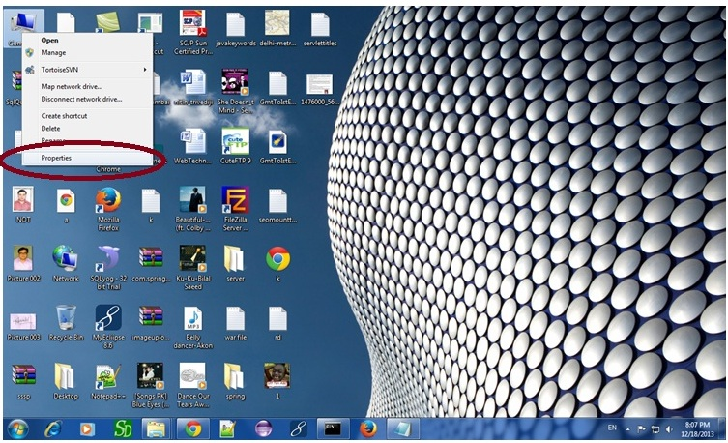

Click on advanced system settings tab then environment variables:

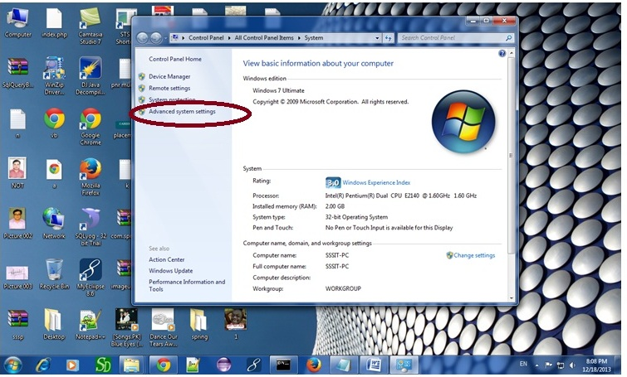

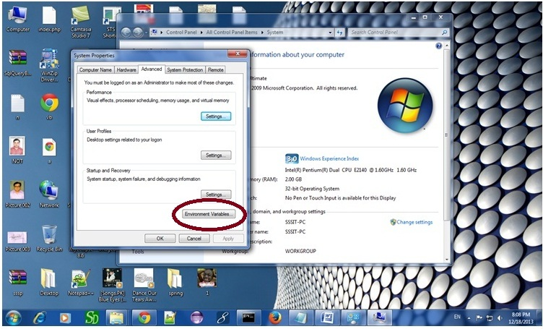

Click on the new tab of user variable or system variable:

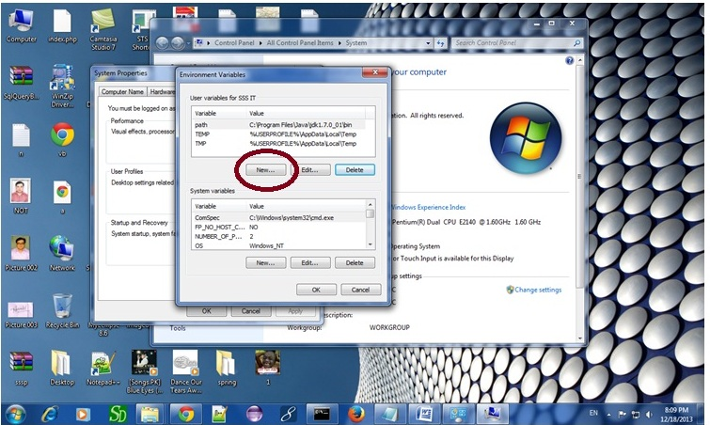

Write JAVA_HOME in variable name and paste the path of jdk folder in variable value:

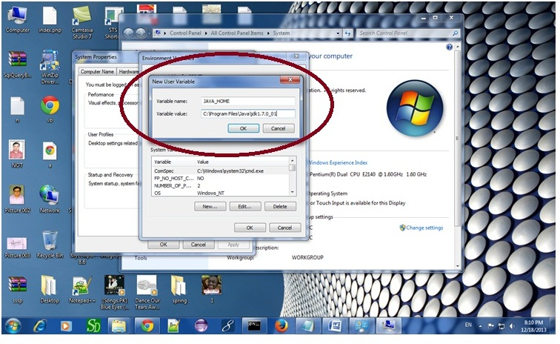

There must not be semicolon (;) at the end of the path.

|  |
| --- |
| After setting the JAVA_HOME double click on the startup.bat file in apache tomcat/bin. |
| Note: There are two types of tomcat available:   1. Apache tomcat that needs to extract only (no need to install) 2. Apache tomcat that needs to install |
| It is the example of apache tomcat that needs to extract only. |

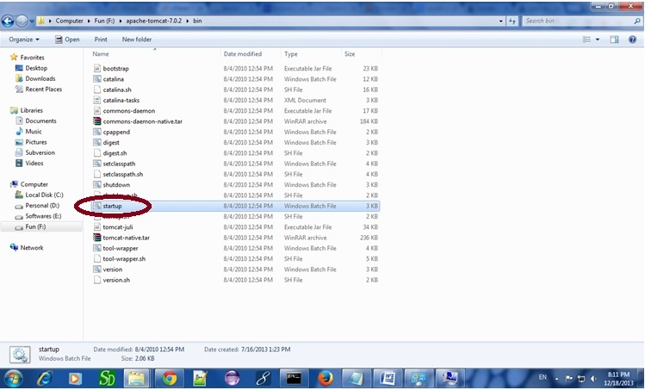

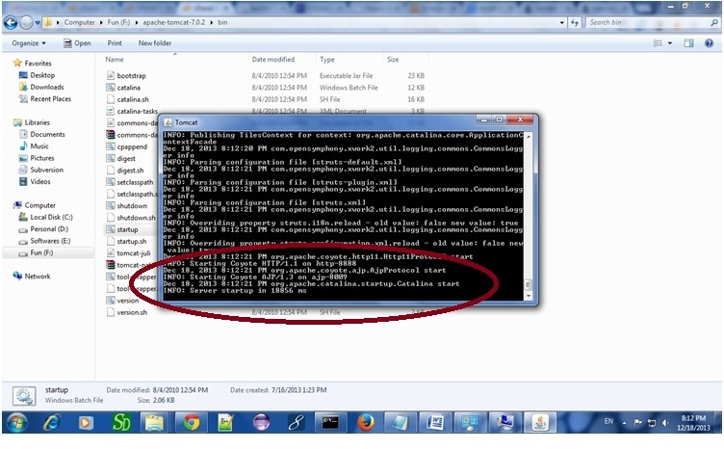

Now server is started successfully.

### 2) How to change port number of apache tomcat

Changing the port number is required if there is another server running on the same system with same port number.Suppose you have installed oracle, you need to change the port number of apache tomcat because both have the default port number 8080.

Open **server.xml file** in notepad. It is located inside the **apache-tomcat/conf** directory . Change the Connector port = 8080 and replace 8080 by any four digit number instead of 8080. Let us replace it by 9999 and save this file.

### 5) How to deploy the servlet project

Copy the project and paste it in the webapps folder under apache tomcat.

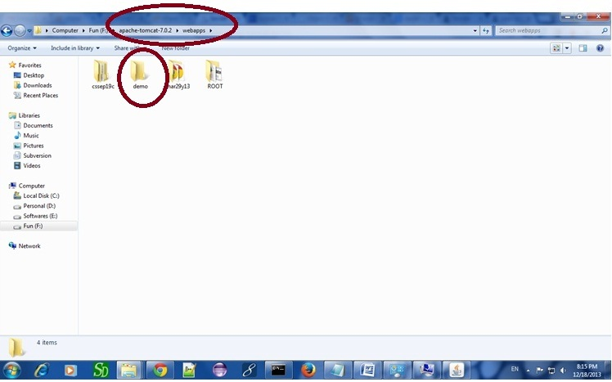

But there are several ways to deploy the project. They are as follows:

* By copying the context(project) folder into the webapps directory
* By copying the war folder into the webapps directory
* By selecting the folder path from the server
* By selecting the war file from the server

Here, we are using the first approach.

You can also create war file, and paste it inside the webapps directory. To do so, you need to use jar tool to create the war file. Go inside the project directory (before the WEB-INF), then write:

1. projectfolder> jar cvf myproject.war *

Creating war file has an advantage that moving the project from one location to another takes less time.

### 6) How to access the servlet

Open broser and write http://hostname:portno/contextroot/urlpatternofservlet. For example:

http://localhost:9999/demo/welcome

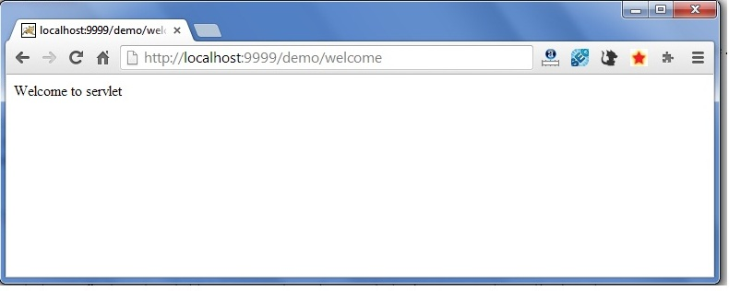

**PROGRAM-13**

**Aim:** Implement a Servlet program for Registration Page.

CREATE TABLE  "REGISTERUSER"

   (    "NAME" VARCHAR2(4000),

    "PASS" VARCHAR2(4000),

    "EMAIL" VARCHAR2(4000),

    "COUNTRY" VARCHAR2(4000)

   )

/

To create the registration page in servlet, we can separate the database logic from the servlet. But here, we are mixing the database logic in the servlet only for simplicity of the program. We will develop this page in JSP following DAO, DTO and Singleton design pattern later.

**Example of Registration form in servlet**

In this example, we have created the three pages.

* register.html
* Register.java
* web.xml

**register.html**

In this page, we have getting input from the user using text fields and combo box. The information entered by the user is forwarded to Register servlet, which is responsible to store the data into the database.

<html>

<body>

<form action="servlet/Register" method="post">

  Name:<input type="text" name="userName"/><br/><br/>

Password:<input type="password" name="userPass"/><br/><br/>

Email Id:<input type="text" name="userEmail"/><br/><br/>

Country:

<select name="userCountry">

<option>India</option>

<option>Pakistan</option>

<option>other</option>

</select>

  <br/><br/>

<input type="submit" value="register"/>

  </form>

</body>

</html>

**Register.java**

This servlet class receives all the data entered by user and stores it into the database. Here, we are performing the database logic. But you may separate it, which will be better for the web application.

**import** java.io.*;

**import** java.sql.*;

**import** javax.servlet.ServletException;

**import** javax.servlet.http.*;

**public** **class** Register **extends** HttpServlet {

**public** **void** doPost(HttpServletRequest request, HttpServletResponse response)

**throws** ServletException, IOException {

  response.setContentType("text/html");

PrintWriter out = response.getWriter();

String n=request.getParameter("userName");

String p=request.getParameter("userPass");

String e=request.getParameter("userEmail");

String c=request.getParameter("userCountry");

**try**{

Class.forName("oracle.jdbc.driver.OracleDriver");

Connection con=DriverManager.getConnection(

"jdbc:oracle:thin:@localhost:1521:xe","system","oracle");

  PreparedStatement ps=con.prepareStatement(

"insert into registeruser values(?,?,?,?)");

  ps.setString(1,n);

ps.setString(2,p);

ps.setString(3,e);

ps.setString(4,c);

**int** i=ps.executeUpdate();

**if**(i>0)

out.print("You are successfully registered...");

**catch** (Exception e2) {System.out.println(e2);}

    out.close();

}

  }

**web.xml file**

The is the configuration file, providing information about the servlet.

<web-app>

 <servlet>

<servlet-name>Register</servlet-name>

<servlet-**class**>Register</servlet-**class**>

</servlet>

  <servlet-mapping>

<servlet-name>Register</servlet-name>

<url-pattern>/servlet/Register</url-pattern>

</servlet-mapping>

  <welcome-file-list>

    <welcome-file>register.html</welcome-file>

</welcome-file-list>

  </web-app>

**Sample Output**: after execution css.html this is output

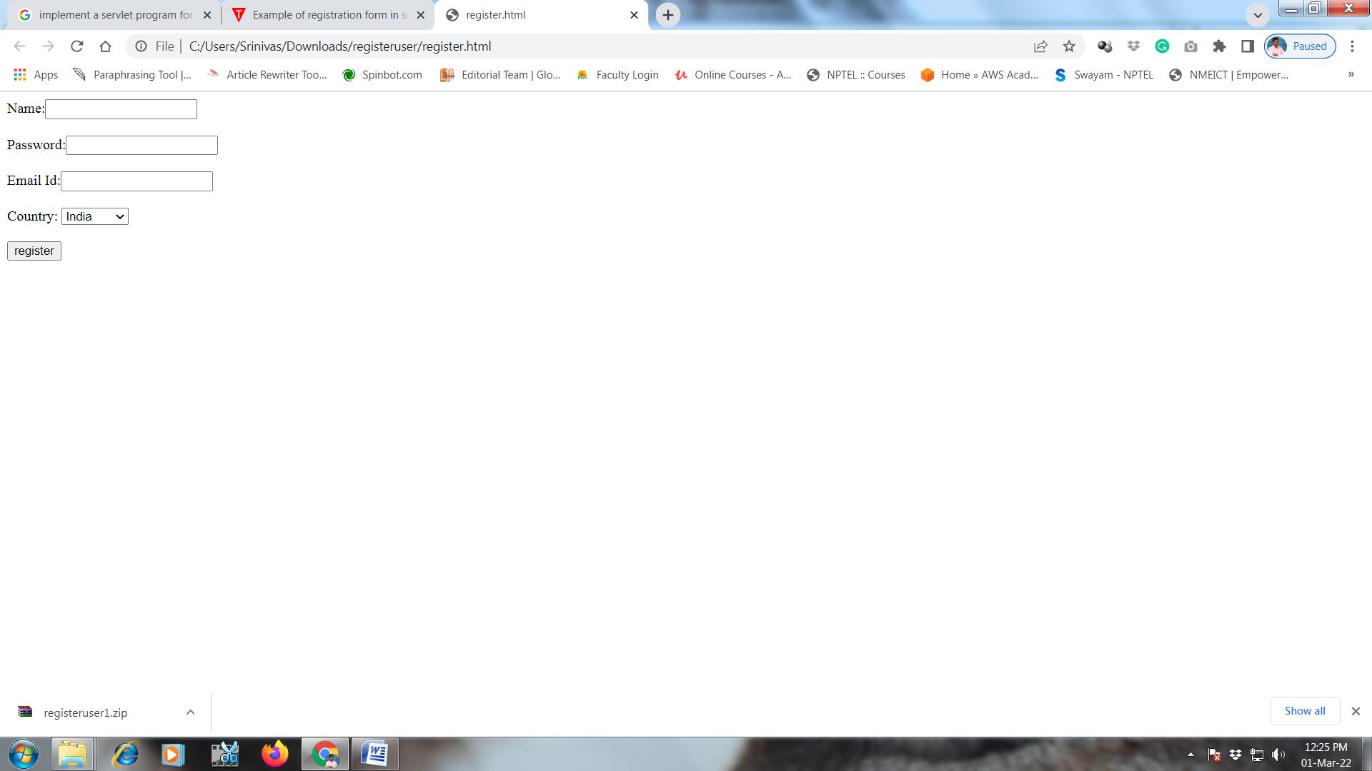

**PROGRAM-14**

**Aim:** Connect to a database using JSP and practice SQL Queries (MySql or Oracle).

The database is used for storing various types of data which are huge and has storing capacity in gigabytes. JSP can connect with such databases to create and manage the records.

In this tutorial, we will learn about how to create a table in the database, and how to create records in these tables through JSP.

In this tutorial, you will learn-

* [Create Table](https://www.guru99.com/jsp-database-connection.html#1)
* [Create Records](https://www.guru99.com/jsp-database-connection.html#2)
* [JSP Operations: Insert, Update, Delete, Select](https://www.guru99.com/jsp-database-connection.html#3)

## Create Table

In MYSQL database, we can create a table in the database with any MYSQL client.

Here we are using PHPMyadminclient, and there we have an option “new” to create a new table using below screenshot.

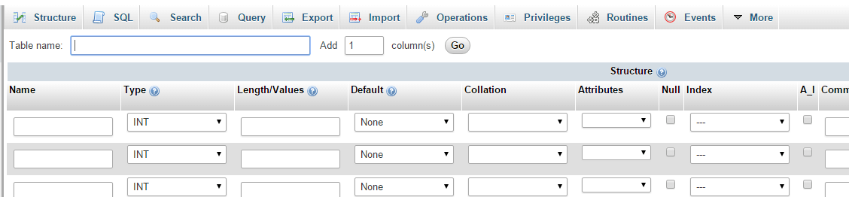

In this, we have to provide table name as guru_test, and we will create two fields’emp_id and emp_name.

Emp_idis havingdatatype as int

Emp_nameis havingdatatype as varchar

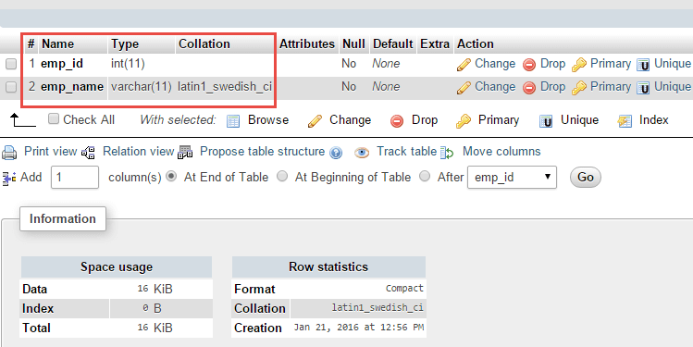

Another option is by using command prompt and changes to MYSQL directory:

**C:\>**

**C:\>cd Program Files\MY SQL\bin**

**C:\>Program Files\MySql\bin>**

We can login to database as follows:

**C:\Program Files\MYSQL\bin>mysql –u gururoot –p**

**Enter Password: \*\*\*\*\*\*\***

**Mysql>**

Create table guru_testin the database named as GuruTestas the following on MYSQL prompt:

Mysql> use GuruTest;

MySql> create table guru_test(

Emp_idint NOT NULL,

Emp_namevarchar(11),

);

Once you execute this you get the following:

Query OK, 0 rows affected(0.10 sec)

MySQl> select * from guru_test;

Query OK, 0 rows affected(0.10 sec)

First the records are inserted using **INSERT** query and then we can use **SELECT**query to check whether the table is created or not.

## Create Records

After creating a table we need to create records into the guru_test table using insert query, which is shown below:

The records entered here are:

* 1 and guru emp1
* 2 and guru emp2

MySql>INSERT INTO `couch_tomato_db`.`guru_test` (`emp_id`, `emp_name`) VALUES ('1', 'guru emp1');

Query OK, 1 row affected (0.05 sec)

MySQL>INSERT INTO `couch_tomato_db`.`guru_test` (`emp_id`, `emp_name`) VALUES ('2', 'guru emp2');

Query OK, 1 row affected (0.05 sec)

## JSP Operations: Insert, Update, Delete, Select

Using JSP, we can do multiple operations into the database. We can insert the records, and also, we can delete the records which are not required. If any record needs to be edited, then we can do using an update. The Selectoperation will help to fetch the records which are required.

**Select**

The Select operation is used to select the records from the table.

**Example**:

In this example, we are going to learn about the select operation of fetching records from guru_test table which was created in the above section.

<%@ page import="java.io.*,java.util.*,java.sql.*"%>

<%@ page import="javax.servlet.http.*,javax.servlet.*" %>

<%@ taglib uri="http://java.sun.com/jsp/jstl/core" prefix="c"%>

<%@ taglib uri="http://java.sun.com/jsp/jstl/sql" prefix="sql"%>

<%@ page language="java" contentType="text/html; charset=ISO-8859-1"

pageEncoding="ISO-8859-1"%>

<!DOCTYPE html PUBLIC "-//W3C//DTD HTML 4.01 Transitional//EN" "http://www.w3.org/TR/html4/loose.dtd">

<html>

<head>

<meta http-equiv="Content-Type" content="text/html; charset=ISO-8859-1">

<title>Guru Database JSP1</title>

</head>

<body>

<sql:setDataSource var="snapshot" driver="com.mysql.jdbc.Driver"

url="jdbc:mysql://localhost/GuruTest"

user="gururoot" password="guru"/>

<sql:query dataSource="${snapshot}" var="result">

SELECT * from guru_test;

</sql:query>

<table>

<tr>

<th>Guru ID</th>

<th>Name</th>

</tr>

<c:forEach var="row" items="${result.rows}">

<tr>

<td><c:out value="${row.emp_id}"/></td>

<td><c:out value="${row.emp_name}"/></td>

</tr>

</c:forEach>

</table>

</body>

</html>

**Output:**

Here both the records will be fetched from the database

1 guru emp1

2 guru emp2

**Insert**

Insert operator is used to insert the records into the database.

**Example:**

In this example, we are going to learn about inserting the records in the table guru_test

<%@ page import="java.io.*,java.util.*,java.sql.*"%>

<%@ page import="javax.servlet.http.*,javax.servlet.*" %>

<%@ taglib uri="http://java.sun.com/jsp/jstl/core" prefix="gurucore"%>

<%@ taglib uri="http://java.sun.com/jsp/jstl/sql" prefix="gurusql"%>

<%@ page language="java" contentType="text/html; charset=ISO-8859-1"

pageEncoding="ISO-8859-1"%>

<!DOCTYPE html PUBLIC "-//W3C//DTD HTML 4.01 Transitional//EN" "http://www.w3.org/TR/html4/loose.dtd">

<html>

<head>

<meta http-equiv="Content-Type" content="text/html; charset=ISO-8859-1">

<title>Guru Database JSP1</title>

</head>

<body>

<gurusql:setDataSource var="guru" driver="com.mysql.jdbc.Driver"

url="jdbc:mysql://localhost/GuruTest"

user="gururoot" password="guru"/>

<gurusql:update dataSource="${guru}" var="guruvar">

INSERT INTO guru_test VALUES (3, 'emp emp3');

</gurusql:update>

</body>

</html>

**Delete**

This is delete operation where we delete the records from the table guru_test.

**Example:**

Here we will delete query to delete the record from the table guru_test. The record which has to be deleted has to be set in variable “guruid”, and the corresponding record is deleted from the database.

<%@ page import="java.io.*,java.util.*,java.sql.*"%>

<%@ page import="javax.servlet.http.*,javax.servlet.*" %>

<%@ taglib uri="http://java.sun.com/jsp/jstl/core" prefix="gurucore"%>

<%@ taglib uri="http://java.sun.com/jsp/jstl/sql" prefix="gurusql"%>

<%@ page language="java" contentType="text/html; charset=ISO-8859-1"

pageEncoding="ISO-8859-1"%>

<!DOCTYPE html PUBLIC "-//W3C//DTD HTML 4.01 Transitional//EN" "http://www.w3.org/TR/html4/loose.dtd">

<html>

<head>

<meta http-equiv="Content-Type" content="text/html; charset=ISO-8859-1">

<title>Guru Database JSP1</title>

</head>

<body>

<gurusql:setDataSource var="guru" driver="com.mysql.jdbc.Driver"

url="jdbc:mysql://localhost/GuruTest"

user="gururoot" password="guru"/>

<gurucore:set var="guruid" value="3"/>

<gurusql:update dataSource="${guru}" var="guruvar">

DELETE FROM guru_test WHERE emp_id = ?

<gurusql:param value="${guruid}" />

</gurusql:update>

</body>

</html>

**Output:**

When you execute the above code, the record with emp_id as 3 is deleted.

**Note:**In this example, we cannot show the output as we are deleting the record from the table.To check whether that record is deleted, we need to use select query “select * from guru_test”. In that case, if we get 3 as emp id then delete query has failed else the record has been deleted successfully.

**Update**

The update is used to edit the records in the table.

**Example:**

<%@ page import="java.io.*,java.util.*,java.sql.*"%>

<%@ page import="javax.servlet.http.*,javax.servlet.*" %>

<%@ taglib uri="http://java.sun.com/jsp/jstl/core" prefix="gurucore"%>

<%@ taglib uri="http://java.sun.com/jsp/jstl/sql" prefix="gurusql"%>

<%@ page language="java" contentType="text/html; charset=ISO-8859-1"

pageEncoding="ISO-8859-1"%>

<!DOCTYPE html PUBLIC "-//W3C//DTD HTML 4.01 Transitional//EN" "http://www.w3.org/TR/html4/loose.dtd">

<html>

<head>

<meta http-equiv="Content-Type" content="text/html; charset=ISO-8859-1">

<title>Guru Database JSP1</title>

</head>

<body>

<gurusql:setDataSource var="guru" driver="com.mysql.jdbc.Driver"

url="jdbc:mysql://localhost/GuruTest"

user="gururoot" password="guru"/>

<gurucore:set var="guruid" value="2"/>

<gurusql:update dataSource="${guru}" var="guruvar">

UPDATE guru_test SET emp_name='emp guru99'

<gurusql:param value="${guruid}" />

</gurusql:update>

</body>

</html>

**Output:**

When you execute the above code the record withemp_id 2 is changed to 99. So, now the output will show emp”guru99″ instead of emp “guru2”.